**Assets – Introduction**

This section documents the visual design assets and wireframes for the POS Inventory System.   
As the UX Lead, I am responsible for defining and documenting the core user flows, screens, and edge cases to ensure clarity, consistency, and smooth handoff to development.

The documentation is structured **by user flow**, with each flow broken down into:

* Primary screens representing the normal path
* Edge cases and error states that impact usability and system feedback

My current focus covers:

**-Sales Checkout flow**

* **Login Sub-Flow** and related edge cases
* **Register selection Sub-Flow** and edge cases
* **Cashier (checkout)Sub-Flow** and edge cases

Each set of screens is designed to reflect the approved requirements, user flows, and UX goals defined in the baseline document, and will be iterated as the product evolves.

**Flow 1 - Sales Checkout**

**Login Sub-Flow – Structure**

**Purpose**   
Allow authorized users to access the system securely and quickly.

**Primary Screens**

1. **Login Screen**
2. Username and password (Login CTA)

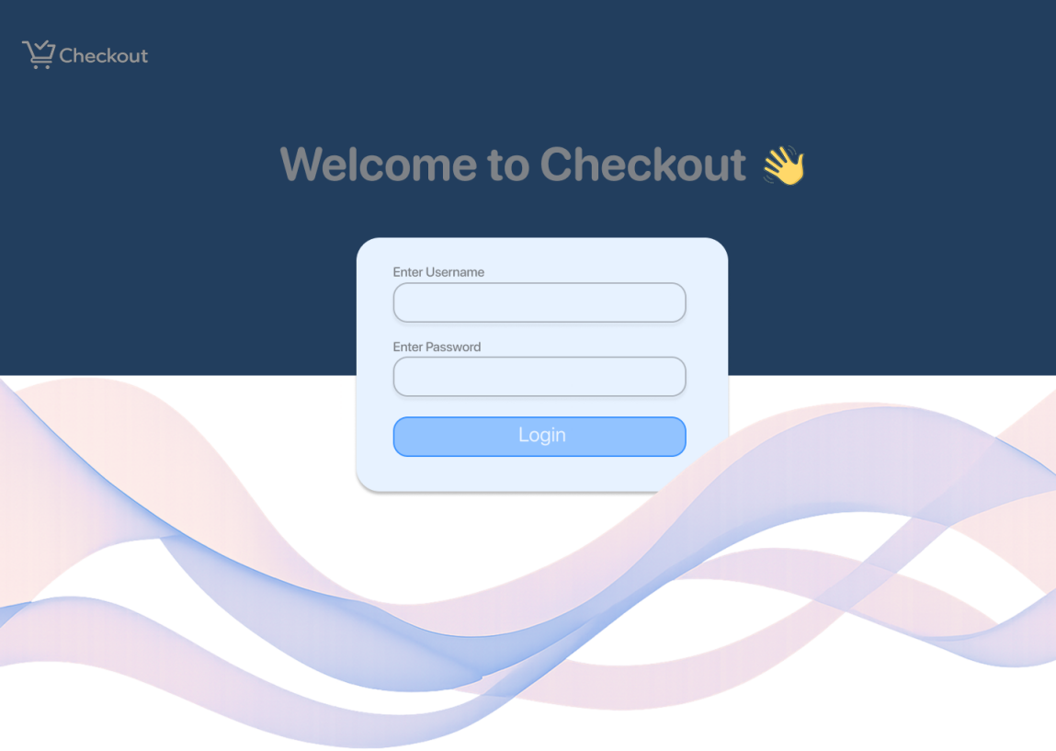

b. Loading state

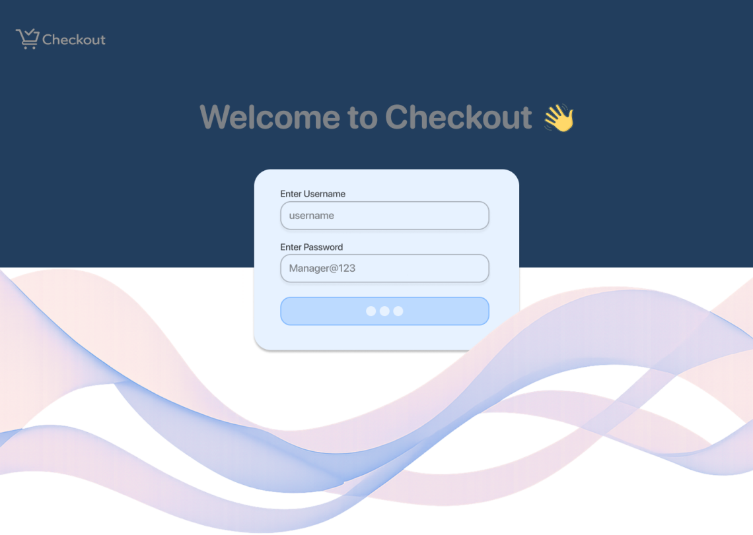

**Happy Path**

* User enters credentials

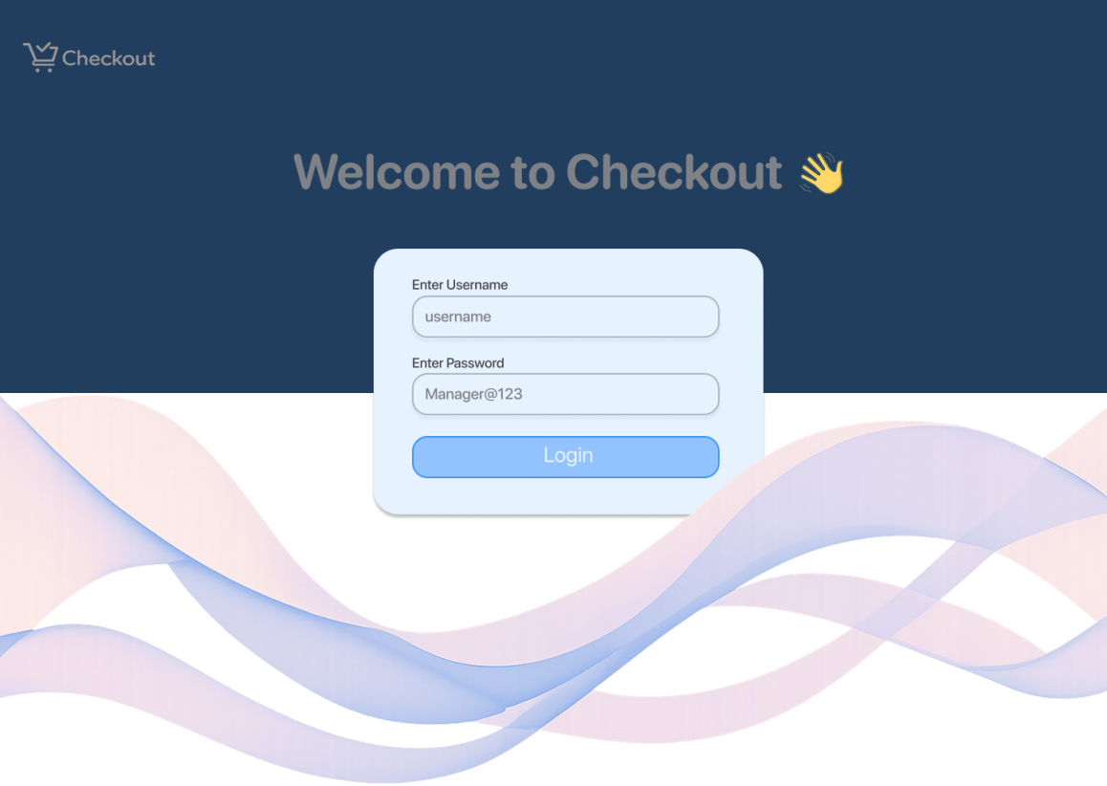

* System validates credentials

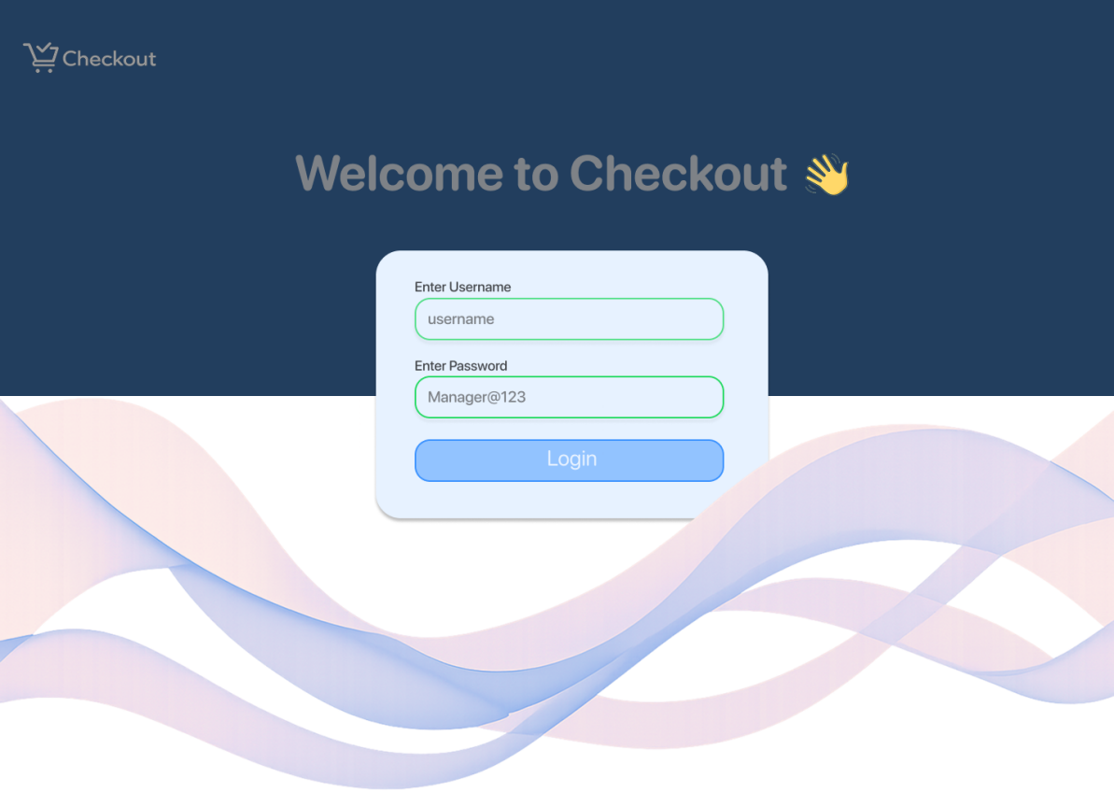

* Successful login → redirect to Register Selection

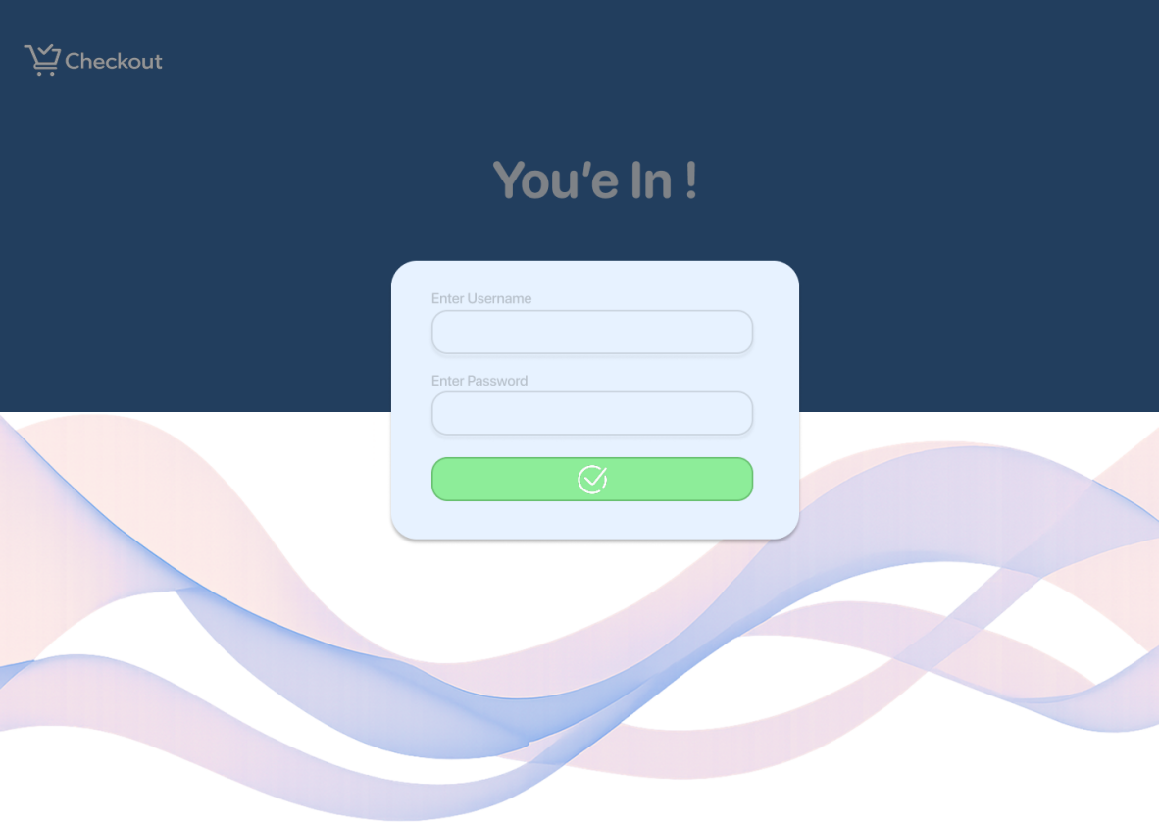

**Edge Cases to Design**

* Invalid username or password

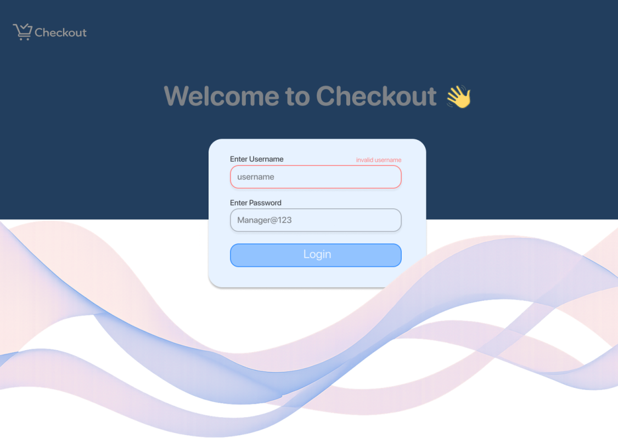

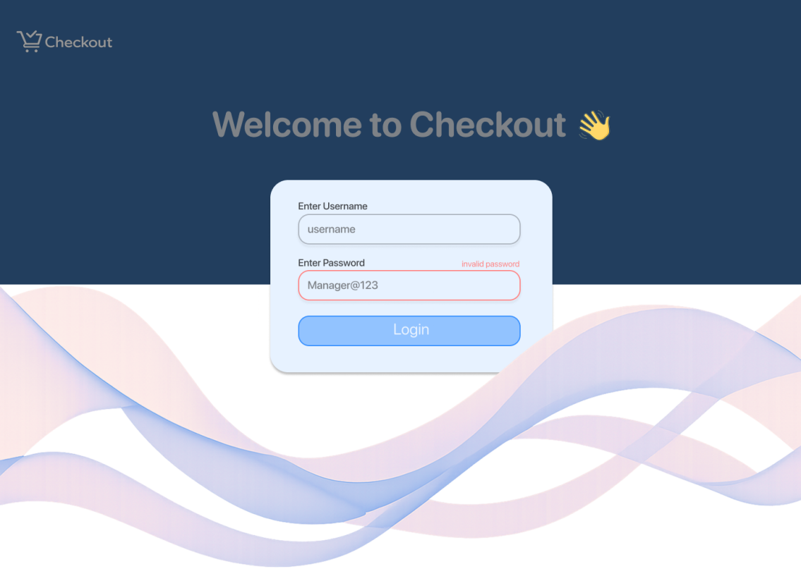

* Empty input fields

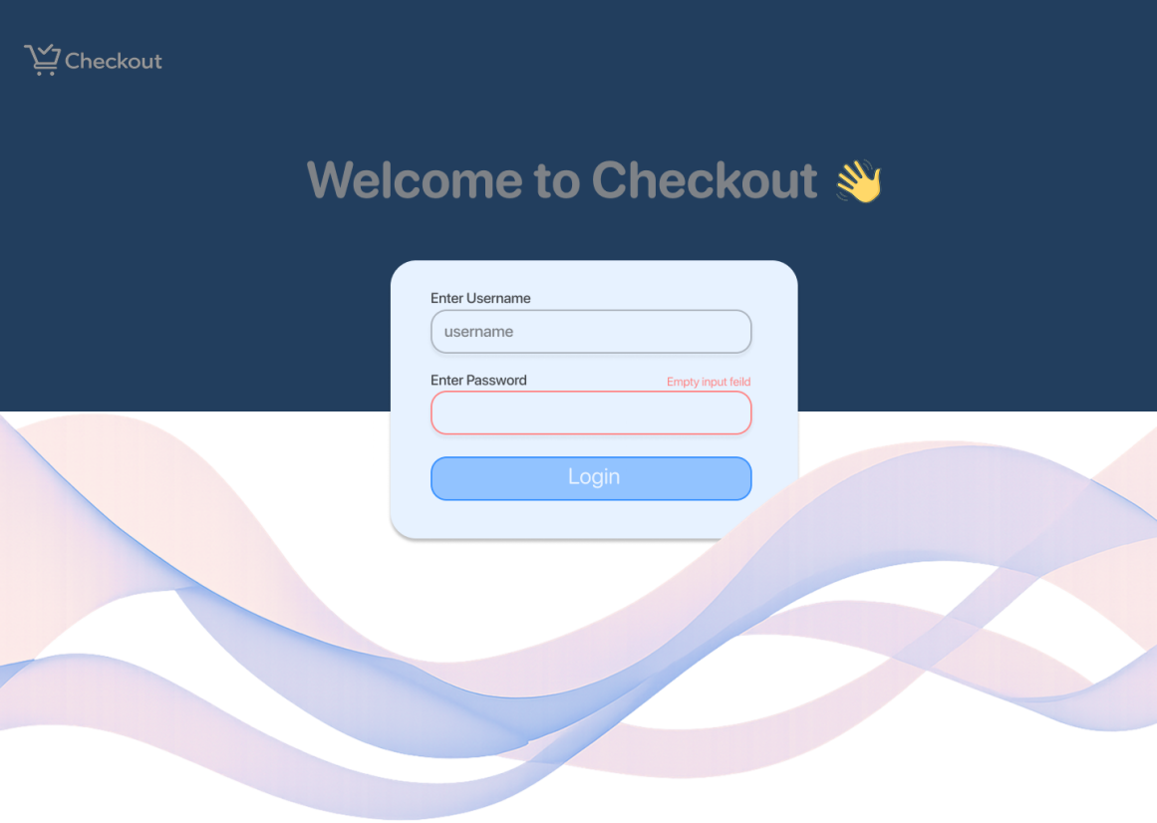

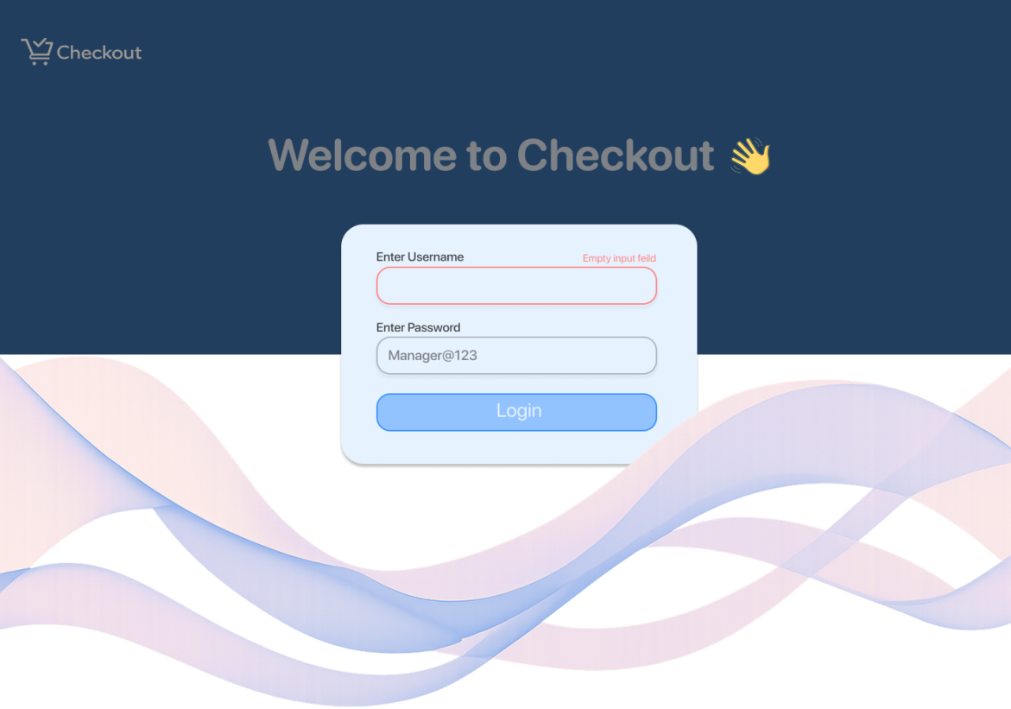

* Account locked or inactive

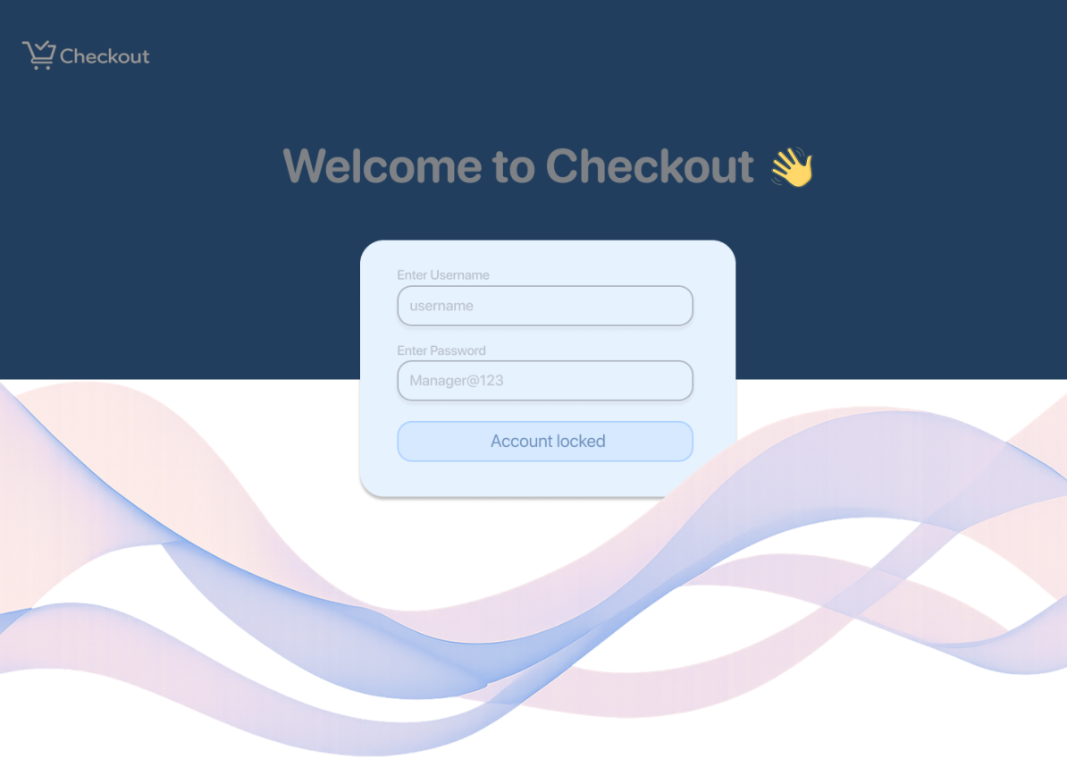

* Network or server error

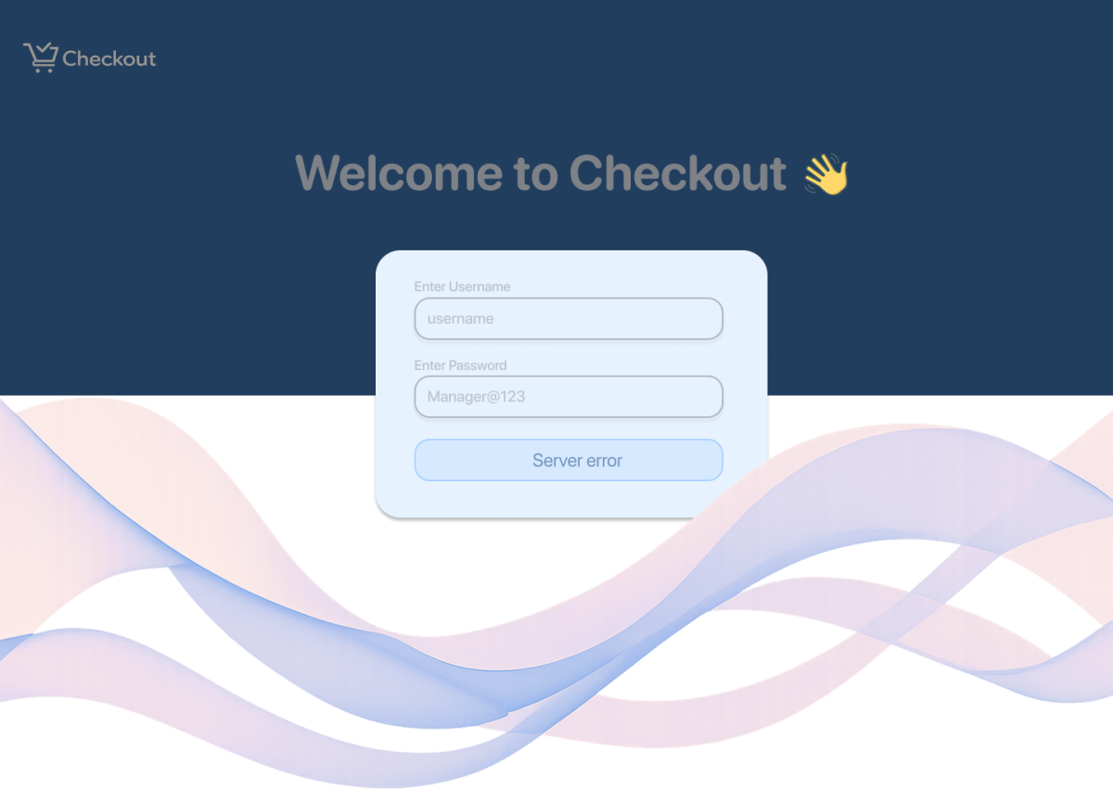

**UX Notes**

* Disable login button during processing
* Visual feedback for success or failure

**Register Selection – Sub-Flow Structure**

**Purpose**Assign the cashier to an active register before starting sales, ensuring accurate session and transaction tracking.

**Primary Screen**

1. **Register Selection Screen**  (Available / In Use)

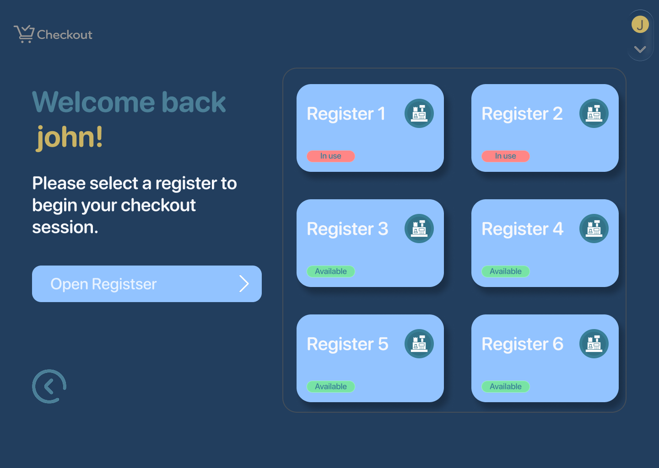

* + List of available registers (Confirm / Continue CTA)

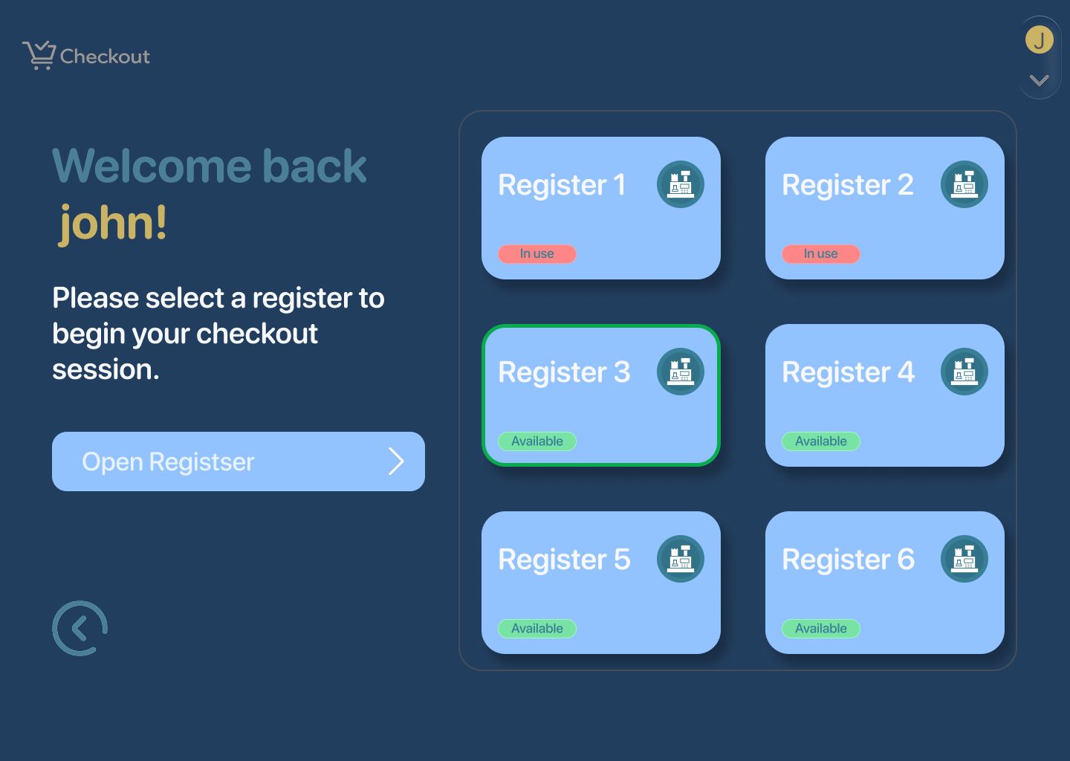

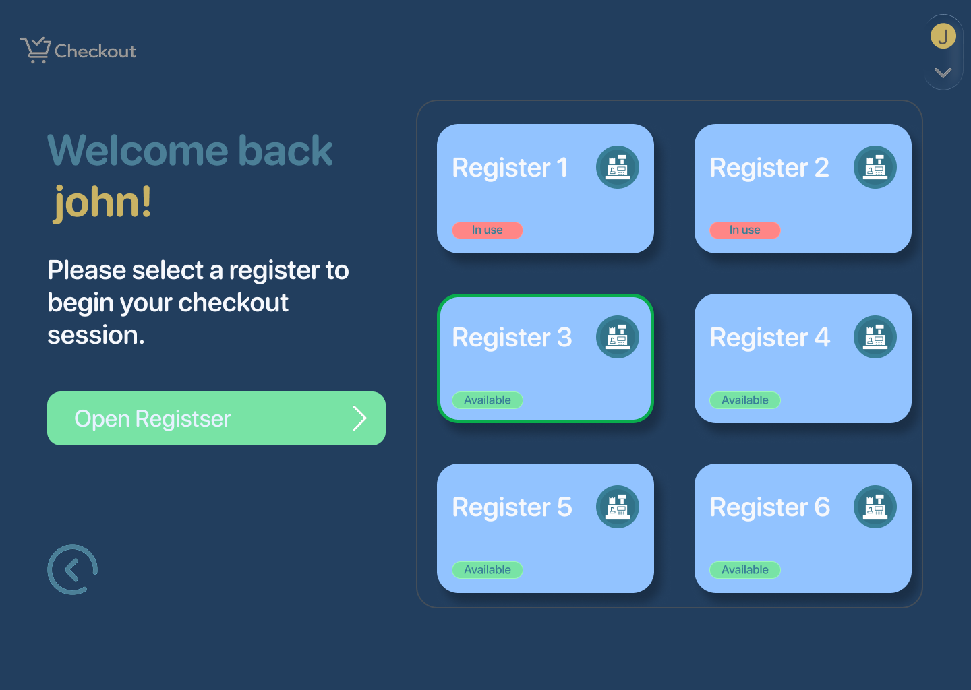

**Edge Cases to Design**

* Register already in use

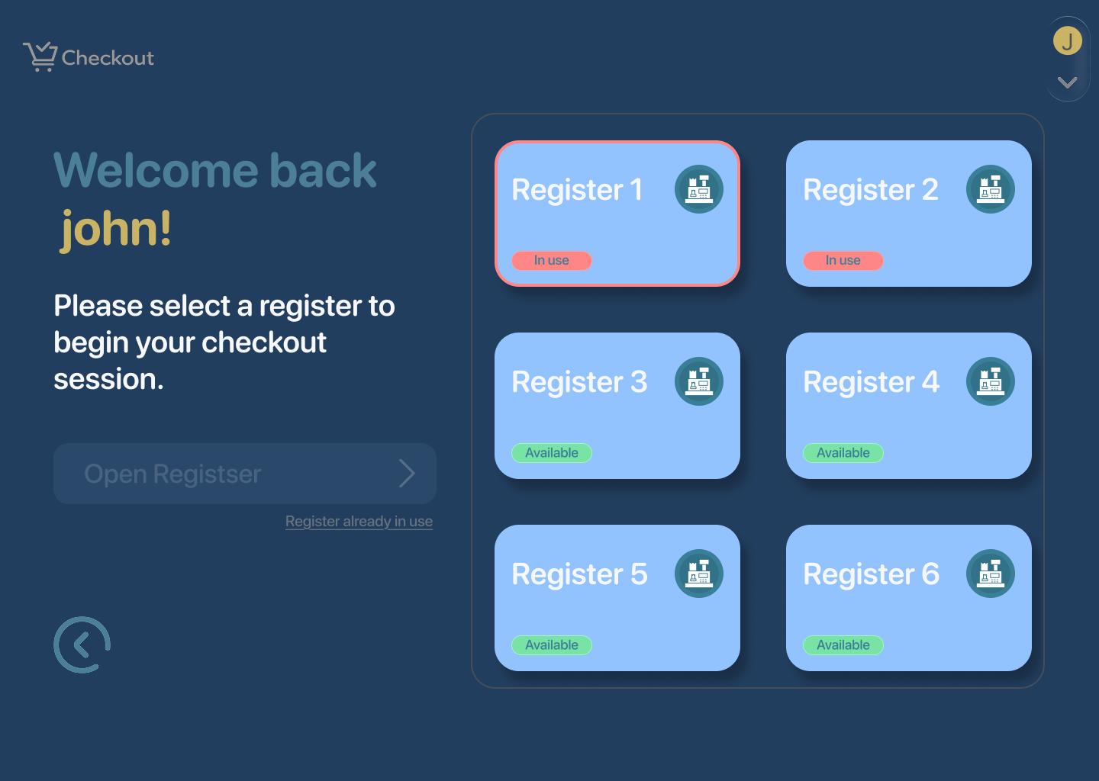

**UX Notes**

* Show only valid, selectable registers
* Clear error and retry options
* Immediate feedback on successful selection

## 

## 

## 

## 

## **POS Checkout Screen- Sub-flow Structure**

### **Key Screen**

**POS Checkout (Main Sales Screen)**This single screen handles scanning, product search, cart review, discounts, payment, and sale completion:

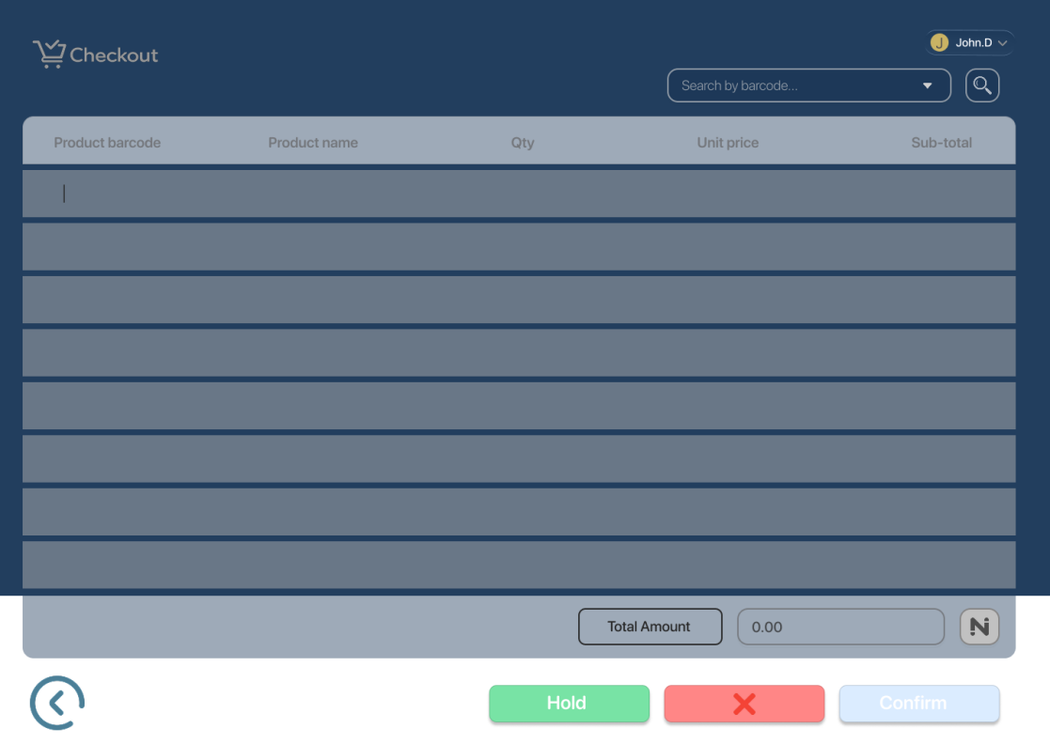

## 

## 

## 

## 

## 

## 

## **Happy Path**

1. **Product Scanned**
   * Scanned products appear

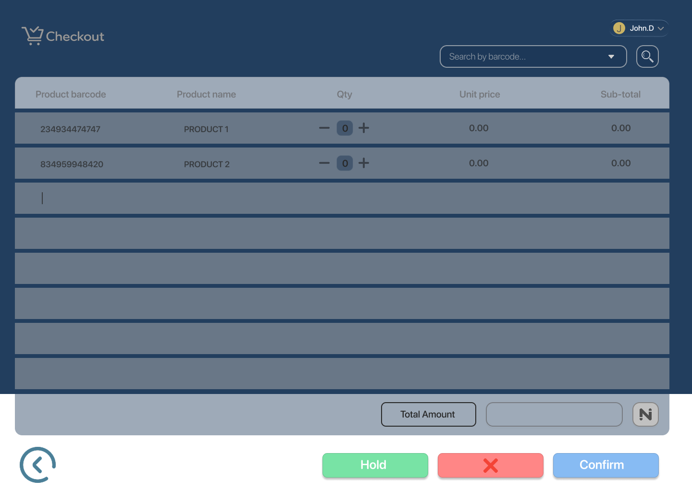

1. **Total Calculated**
   * Total amount auto-calculated for added products

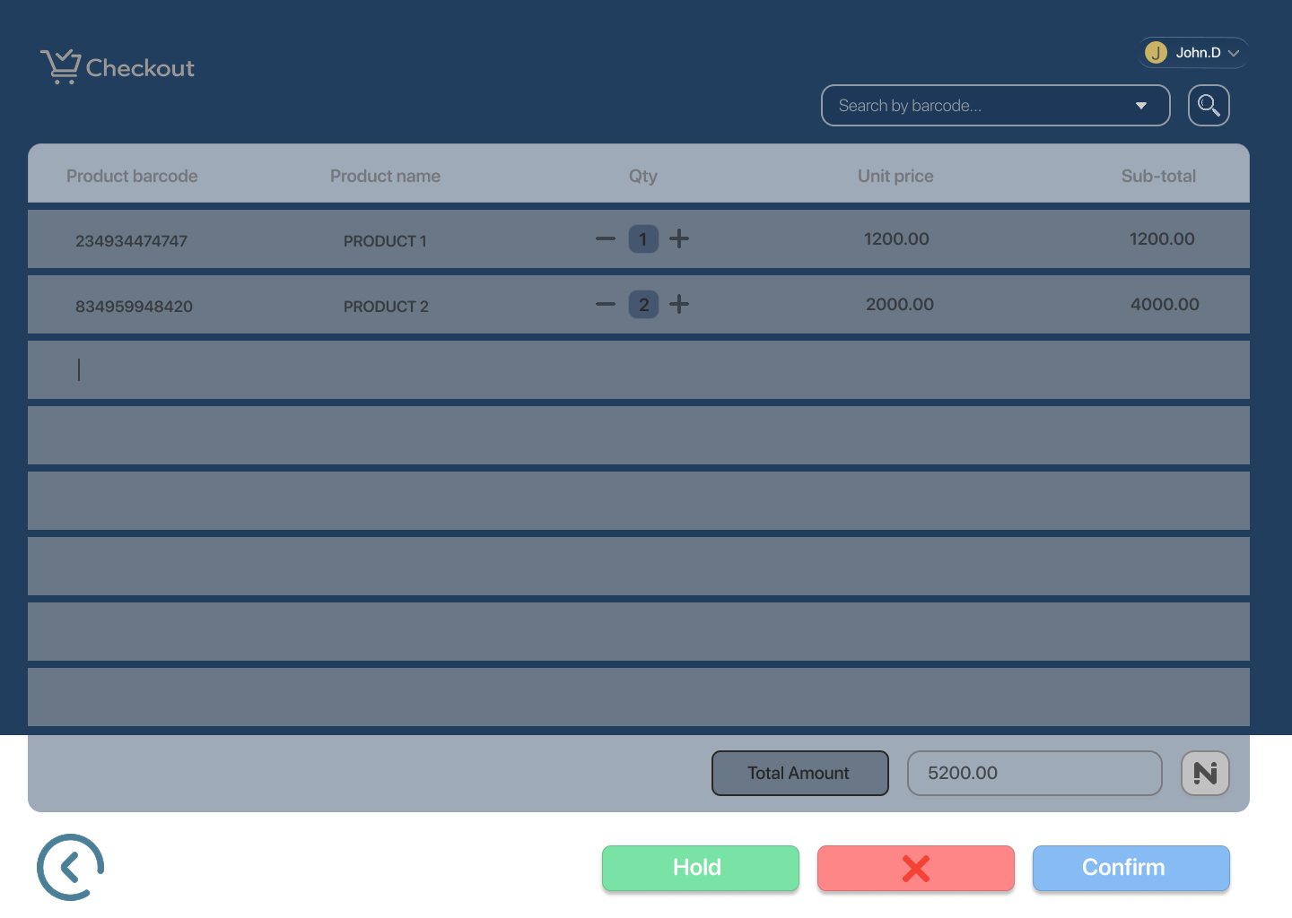

1. **Product Search (Optional)**
   * Search options shown

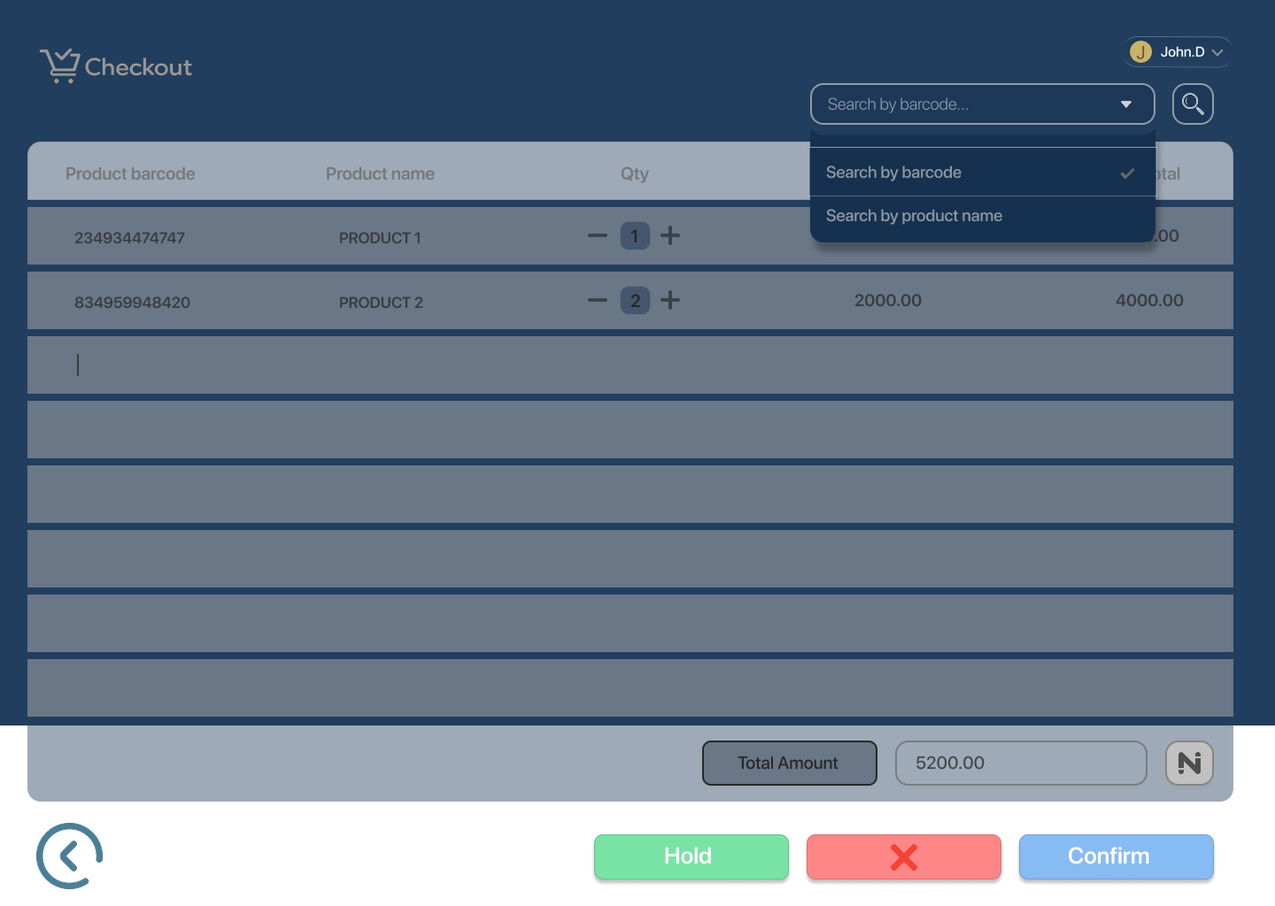

* + Product selected from search

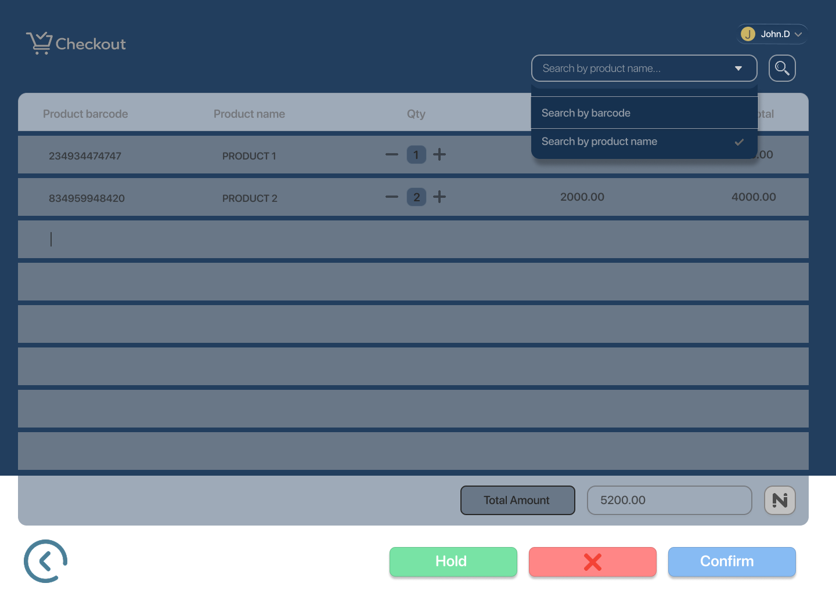

* + Product found

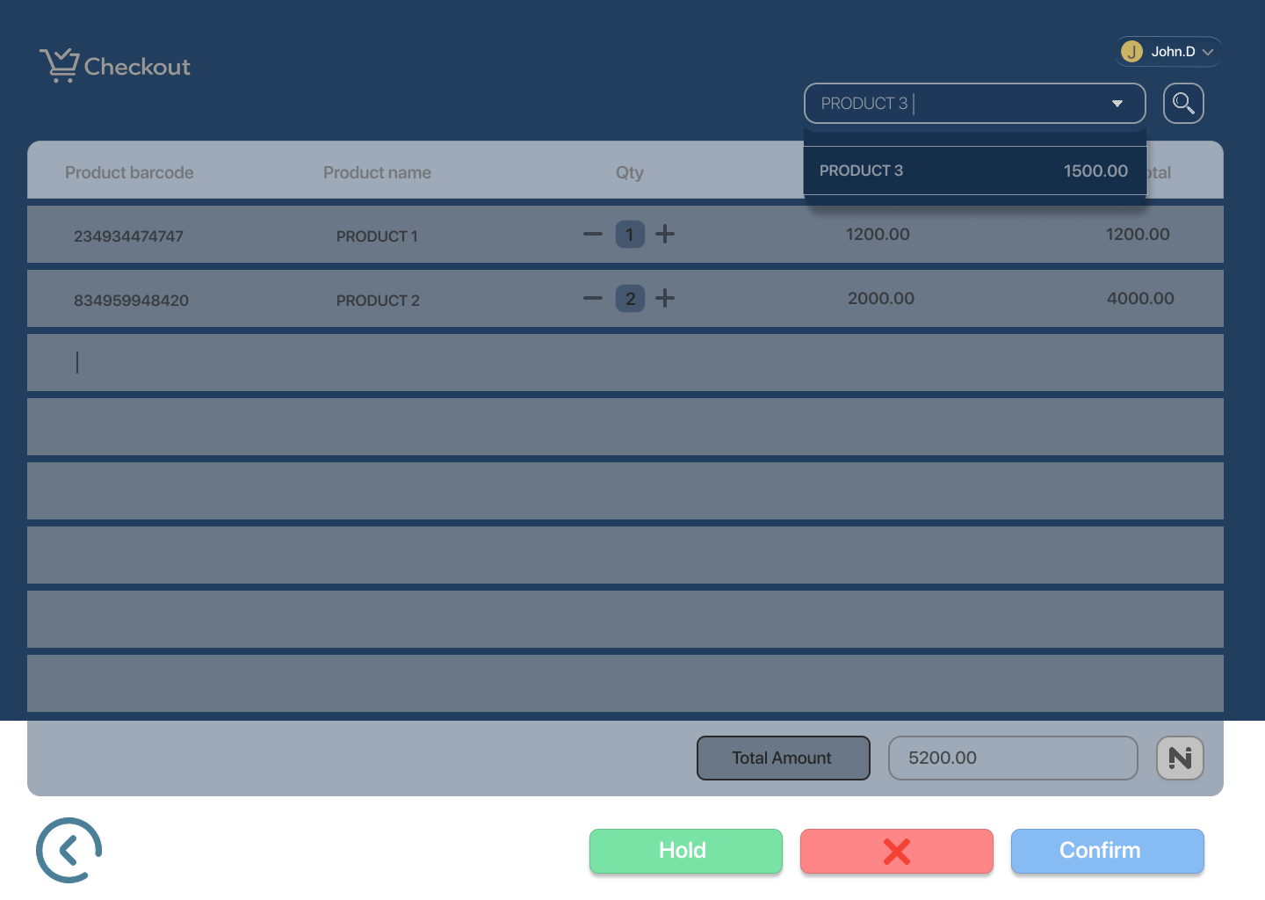

* + Product added to cart

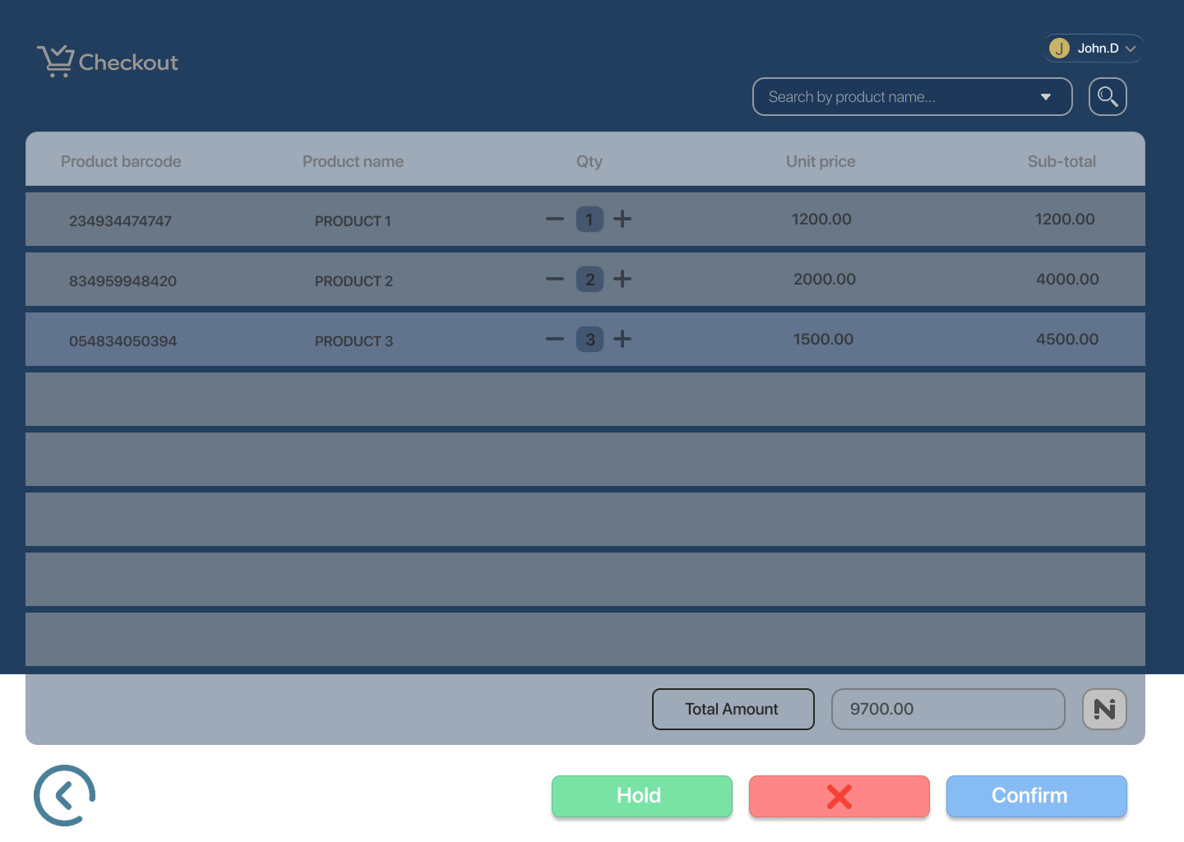

1. **Discount Applied (Optional)**

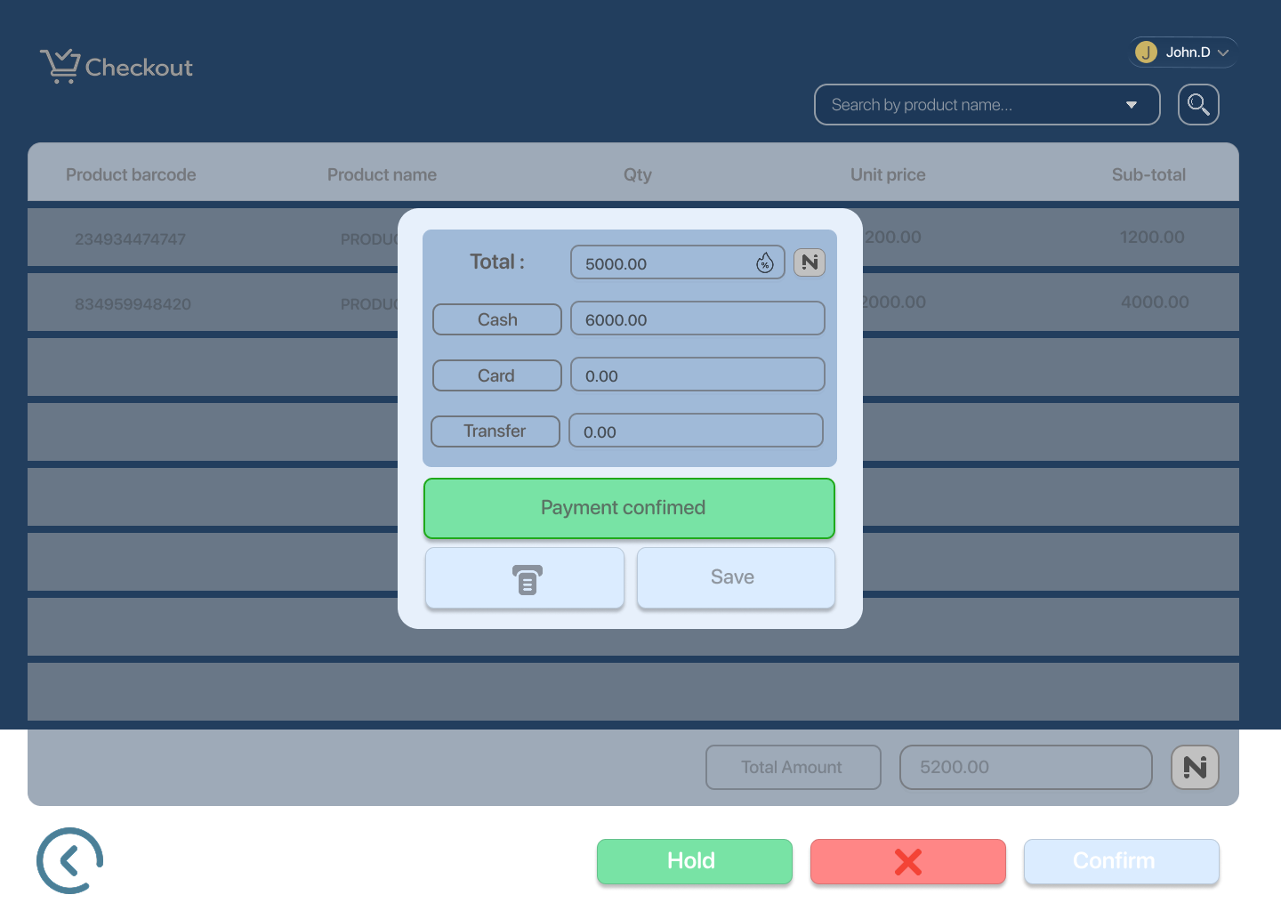

1. **Payment Method Input**

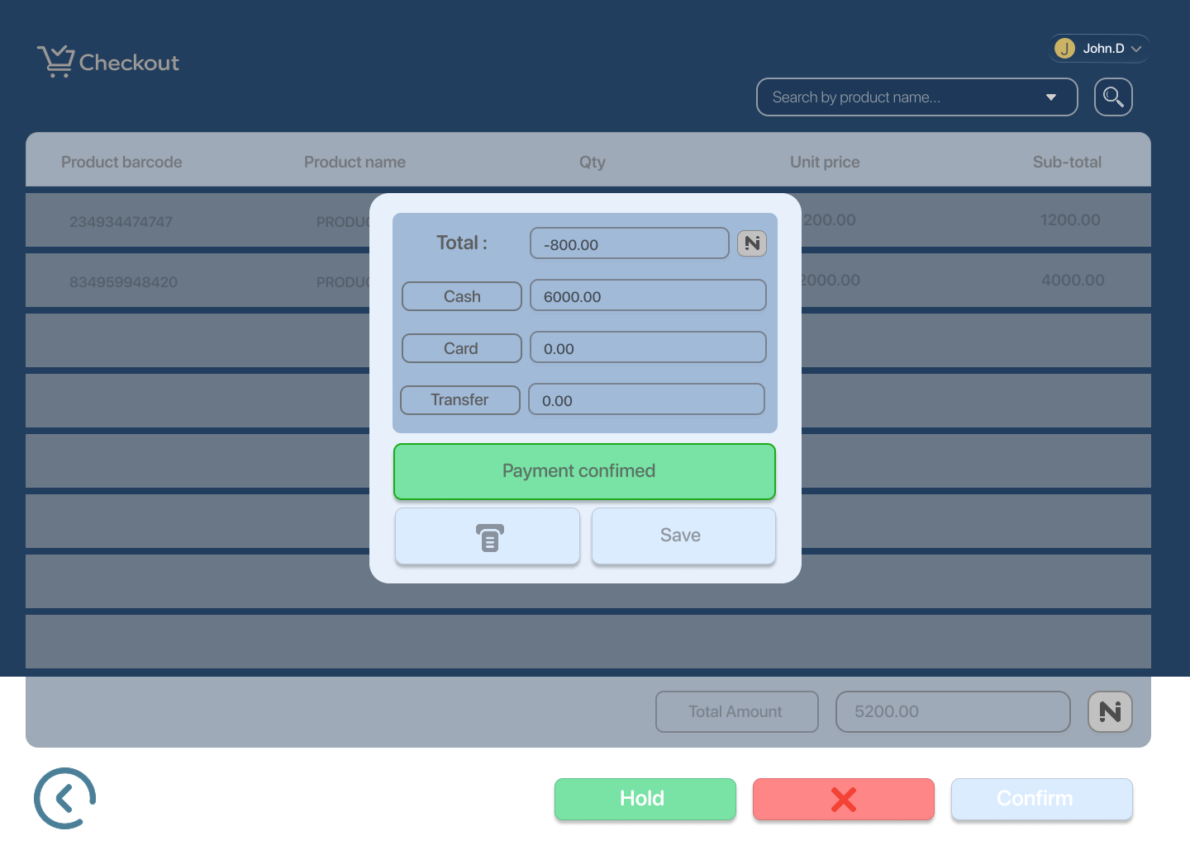

1. **Payment Processing**

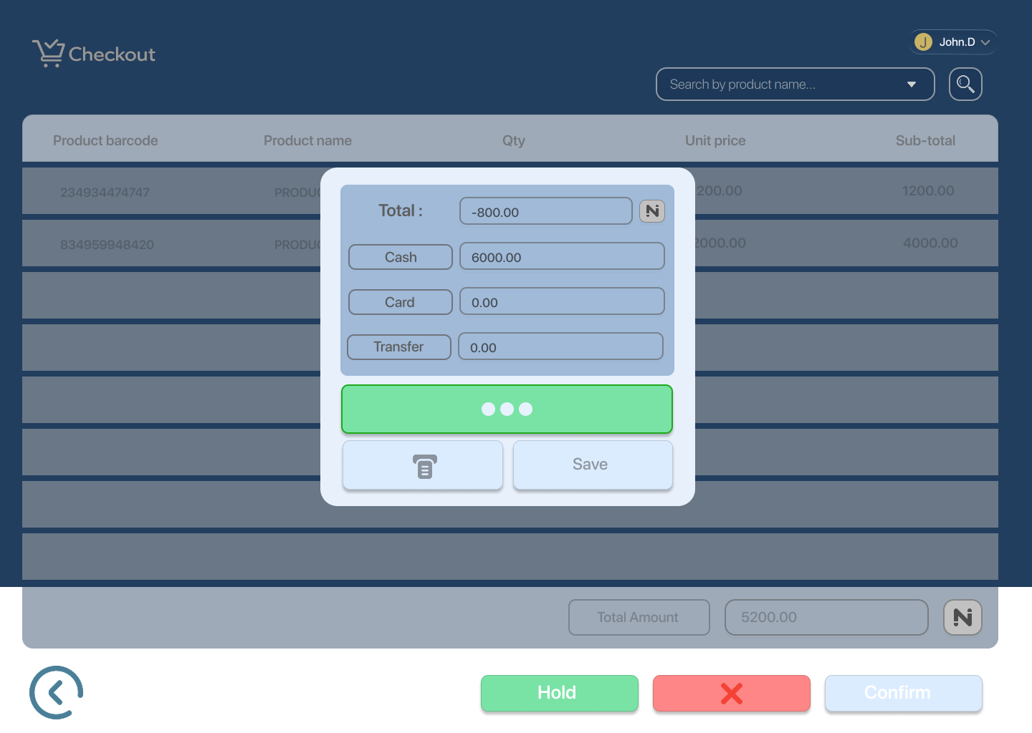

1. **Payment Success**
   * Receipt printed

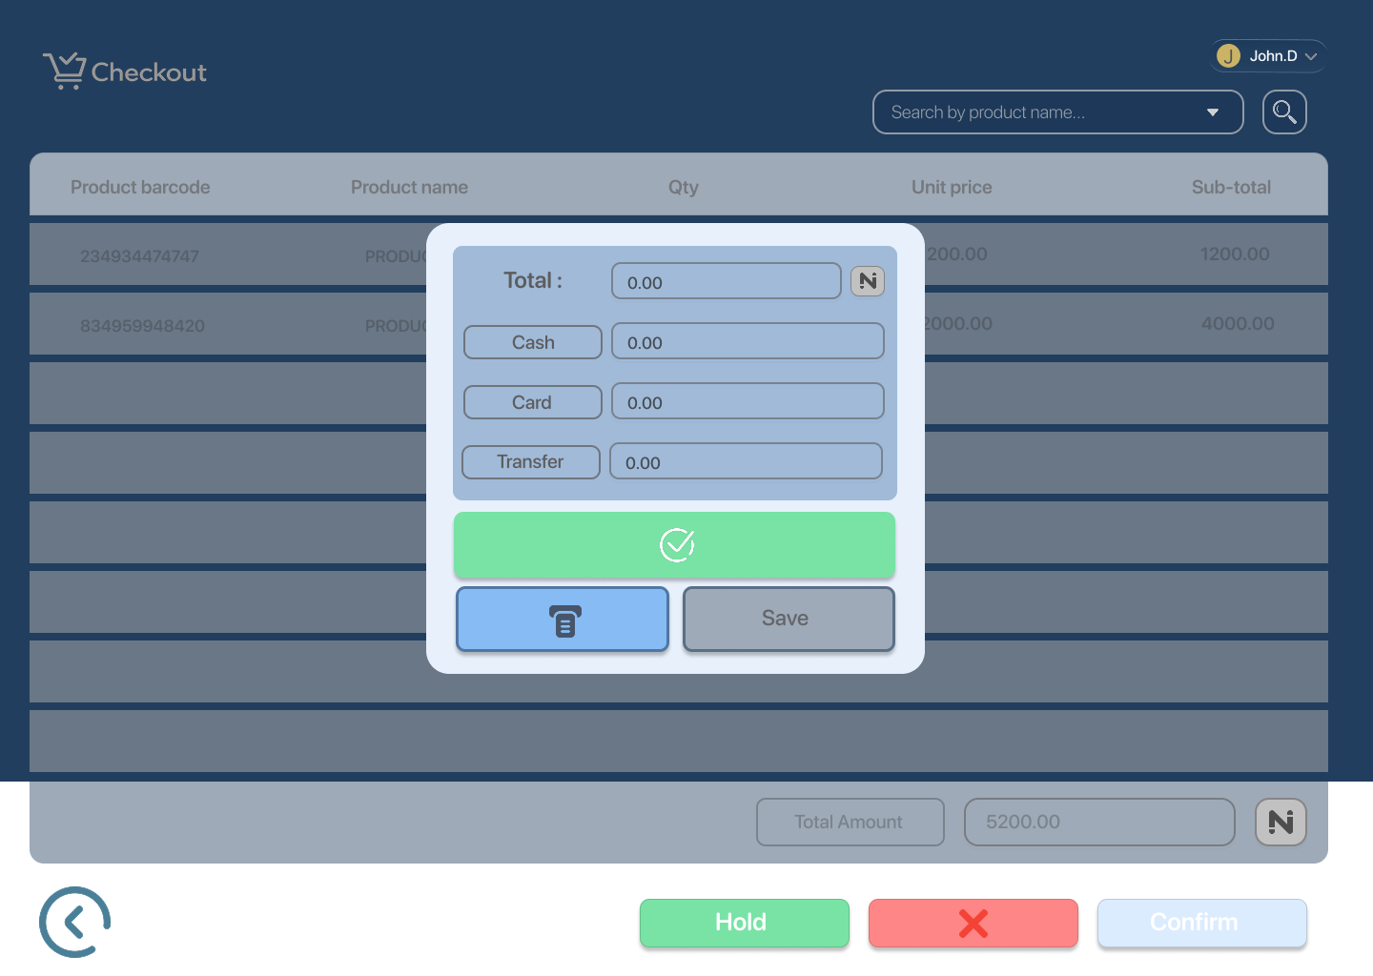

1. **Sale Completed**

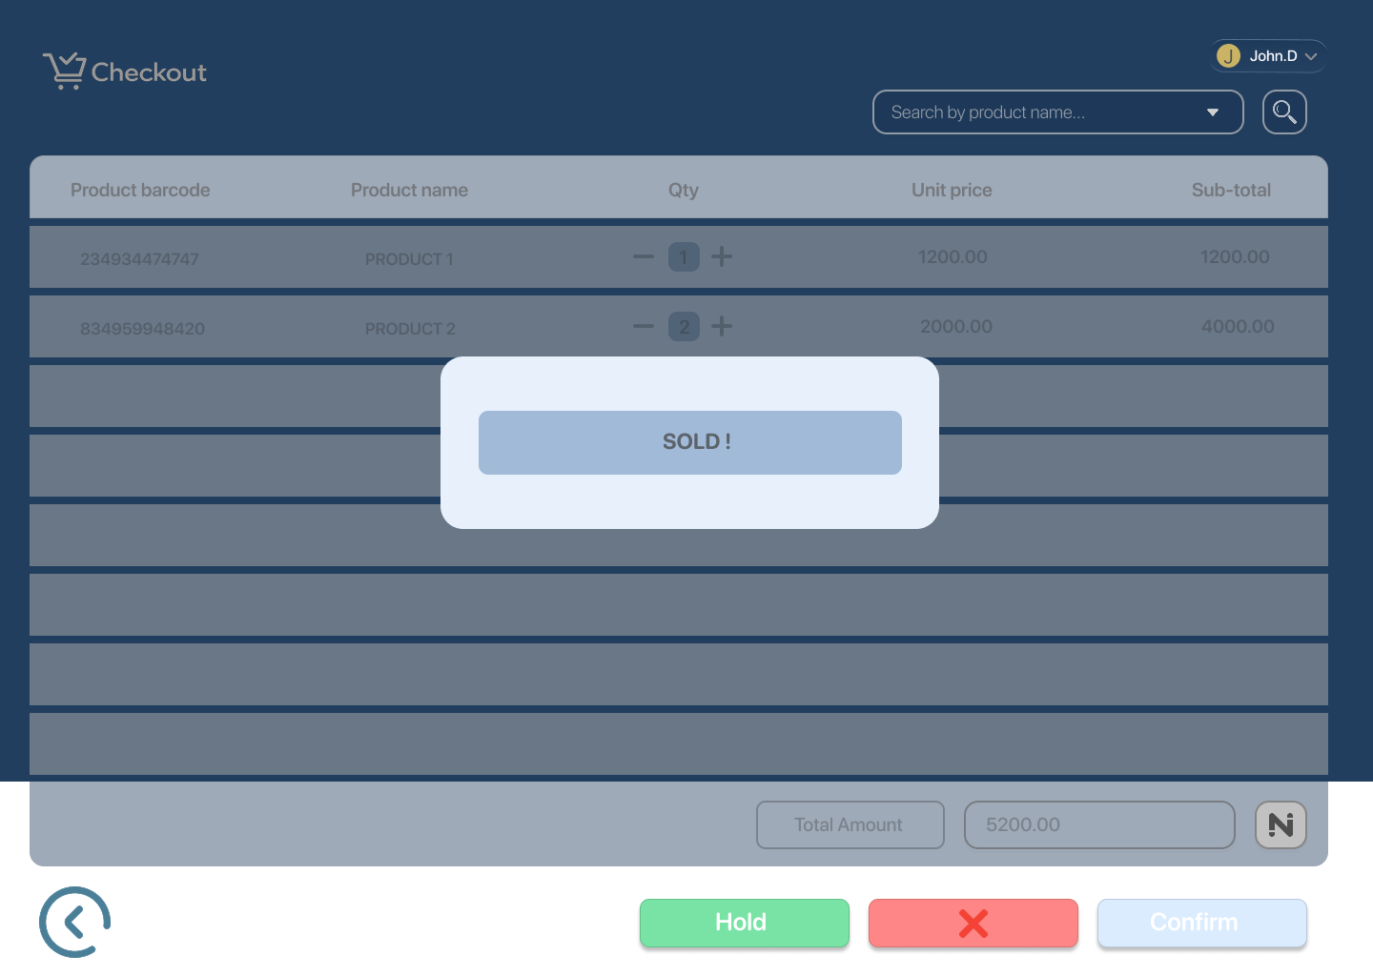

1. **Checkout Cleared**

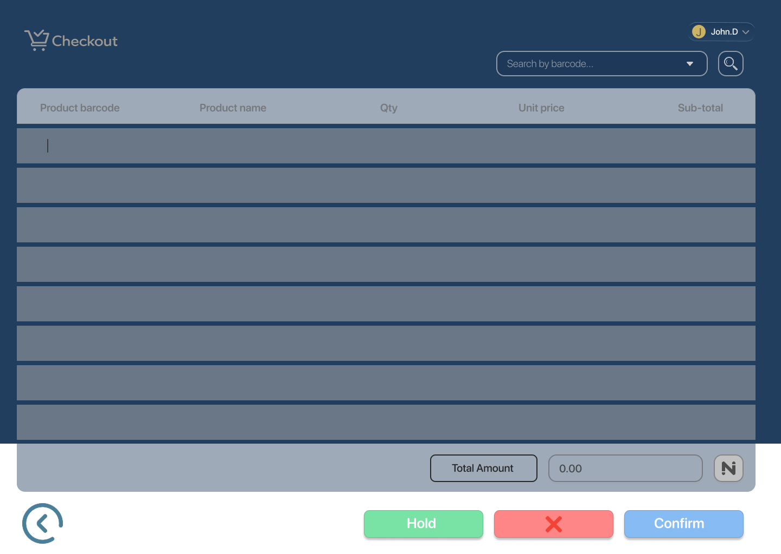

## 

## 

## 

## 

## **Edge Cases / States**

* **Invalid Barcode**

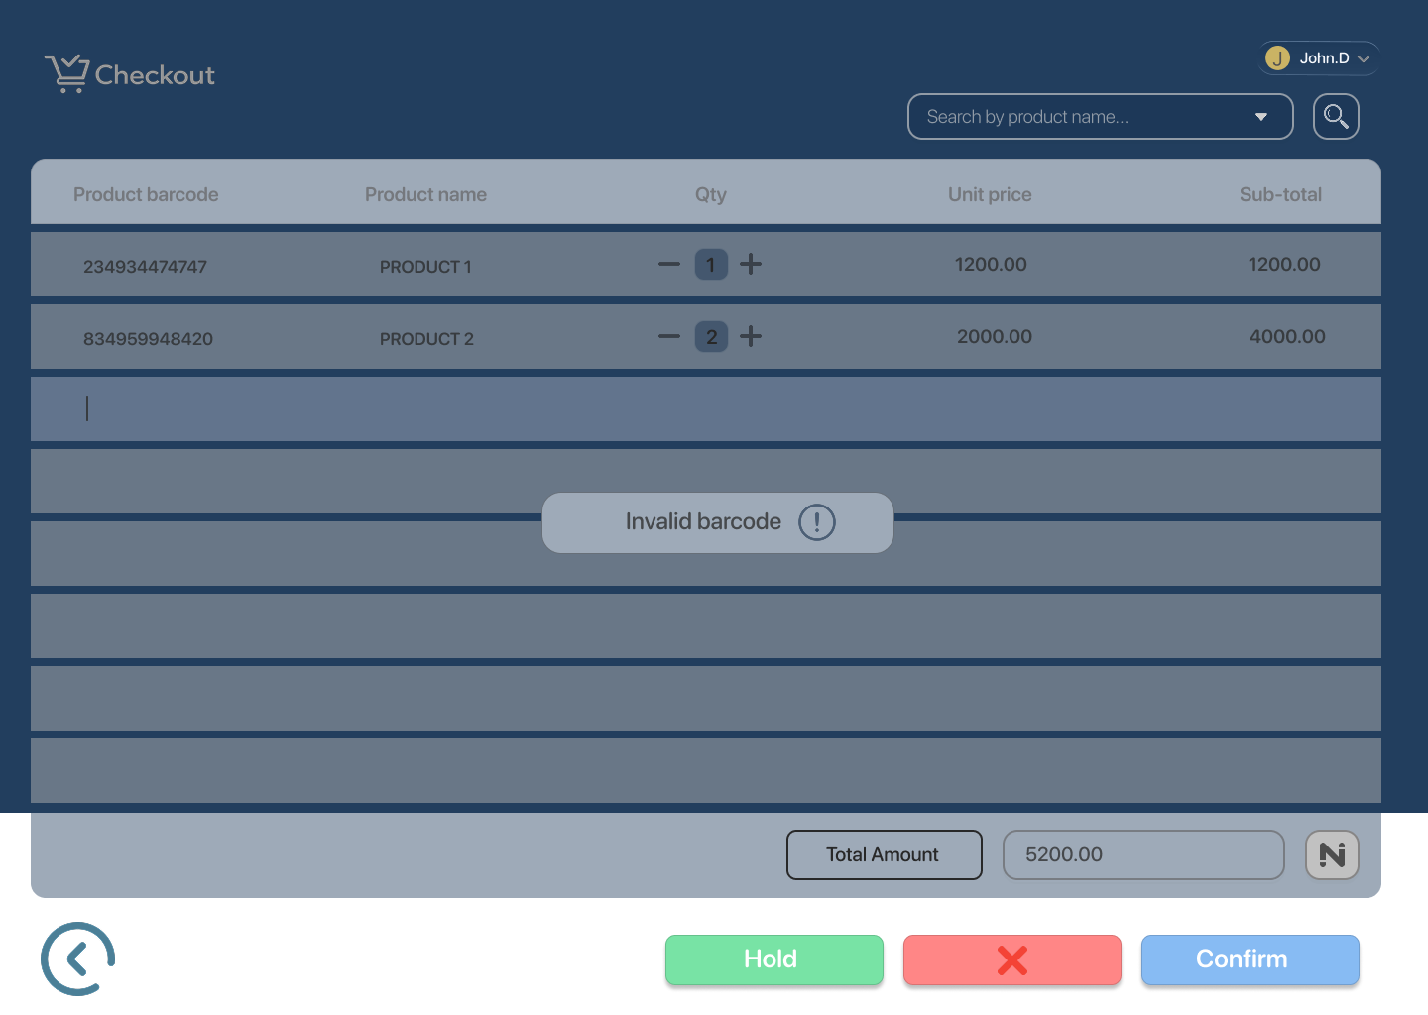

* **Out of Stock**

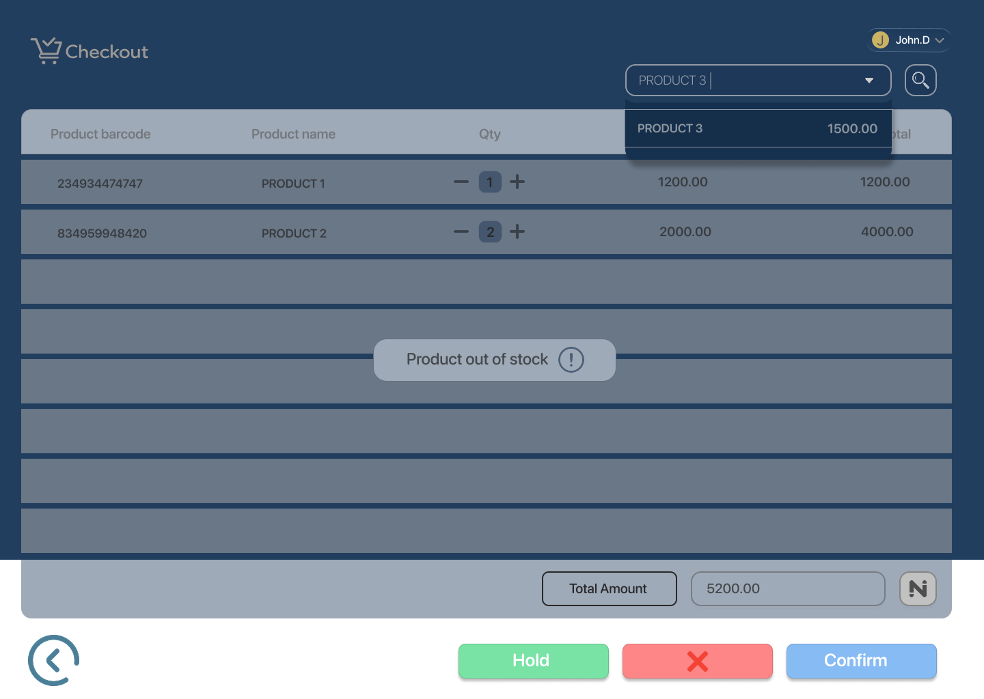

* **Low Stock Warning**

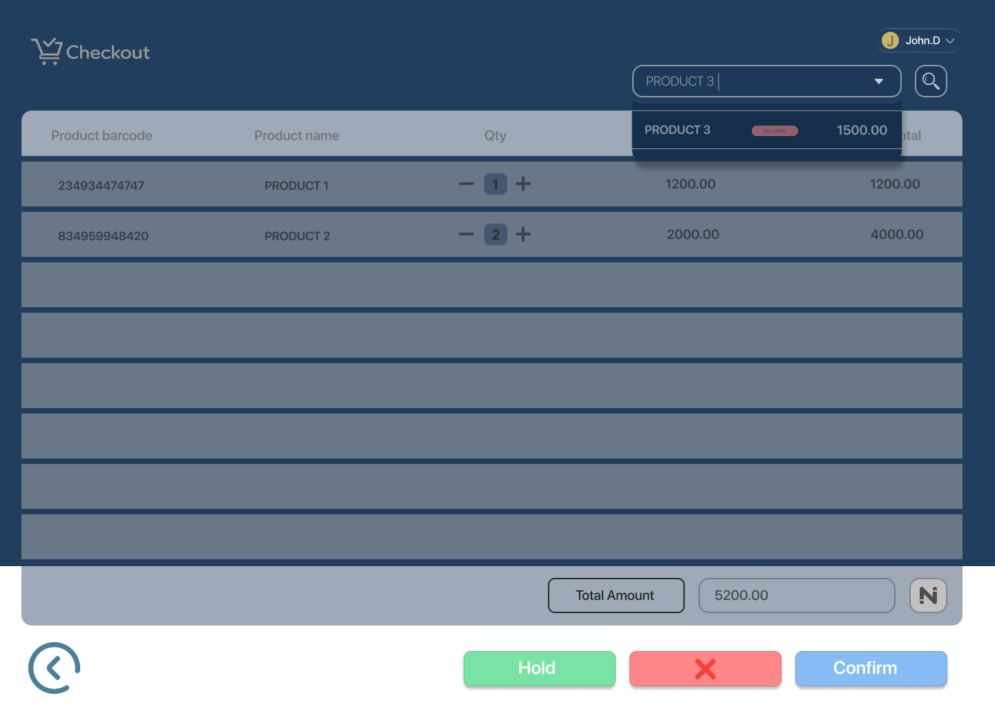

* **Payment Failed**

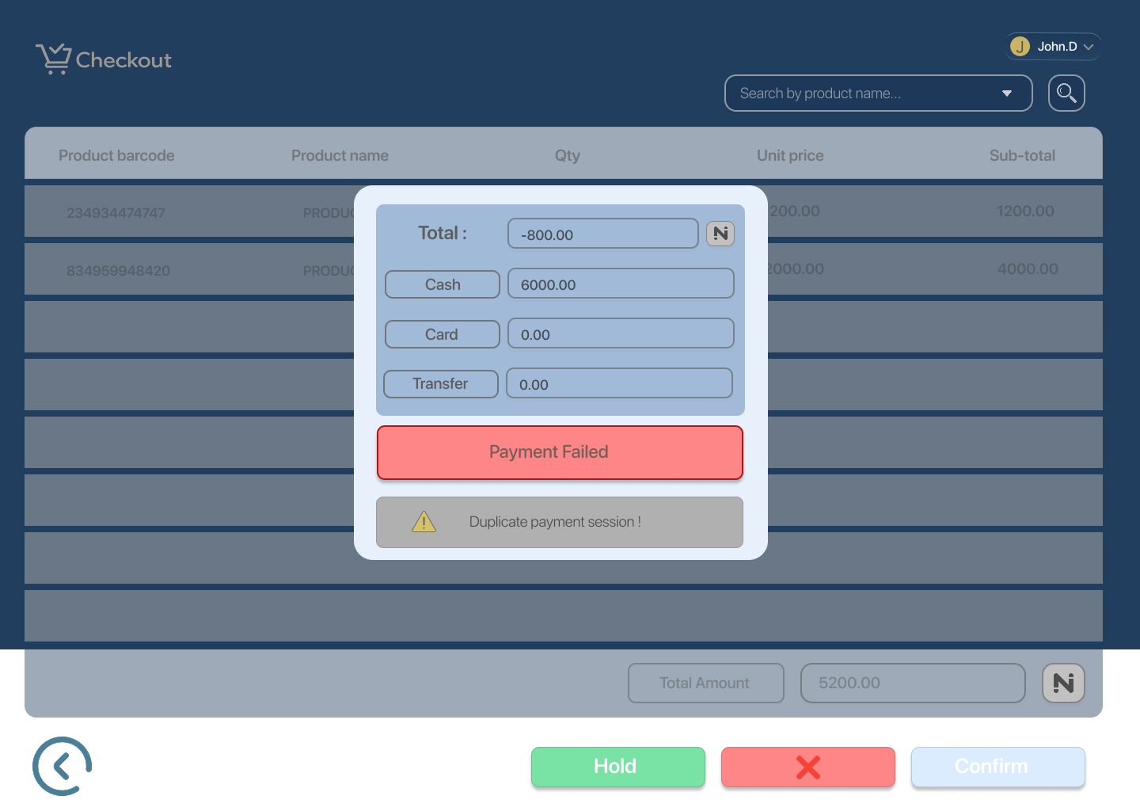

* **Payment Cancelled**

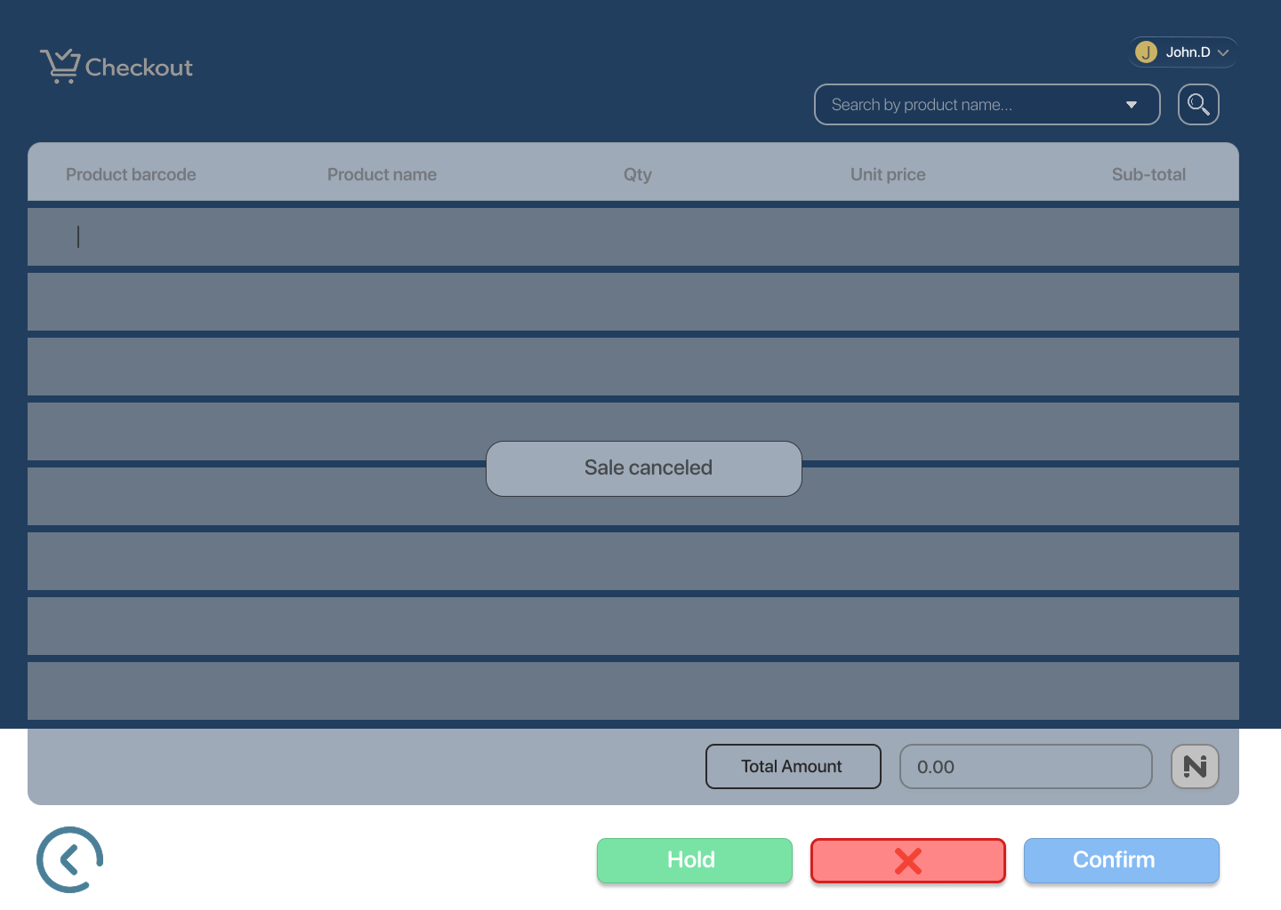

## **UX Notes**

## Checkout operates on a **single continuous screen**

* Real-time updates for scanned products and totals
* Search acts as a fallback to barcode scanning
* Payment has clear processing, success, failure, and cancel states
* System resets automatically after sale completion

## **Item Return Flow — Structure**

### **Happy Path**

**Item return 1**  
Return initiated

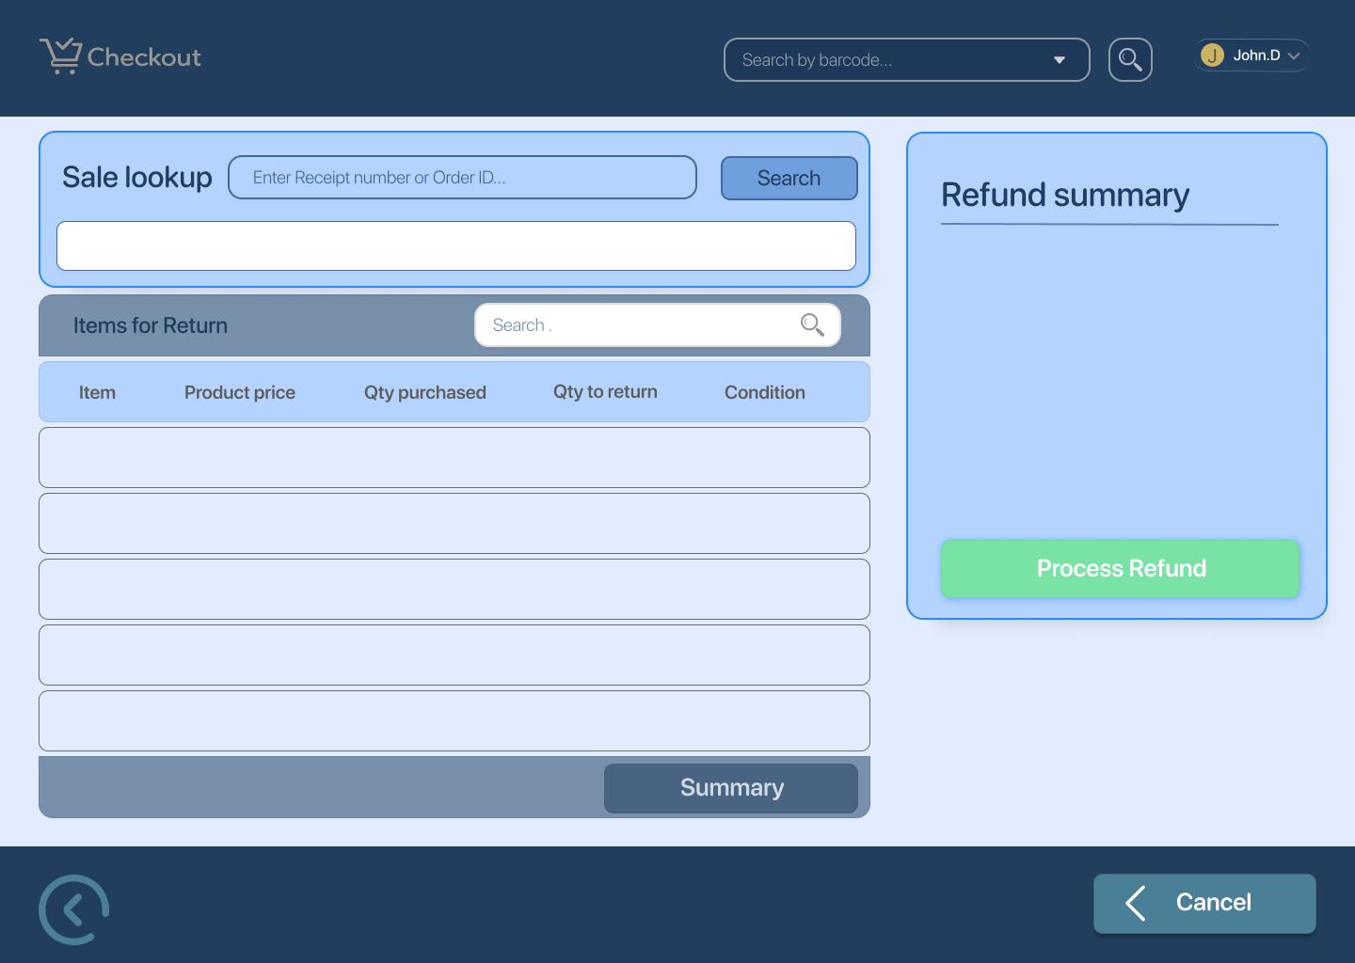

**Item return 2 – Order found and items added**  
System finds order and loads purchased items

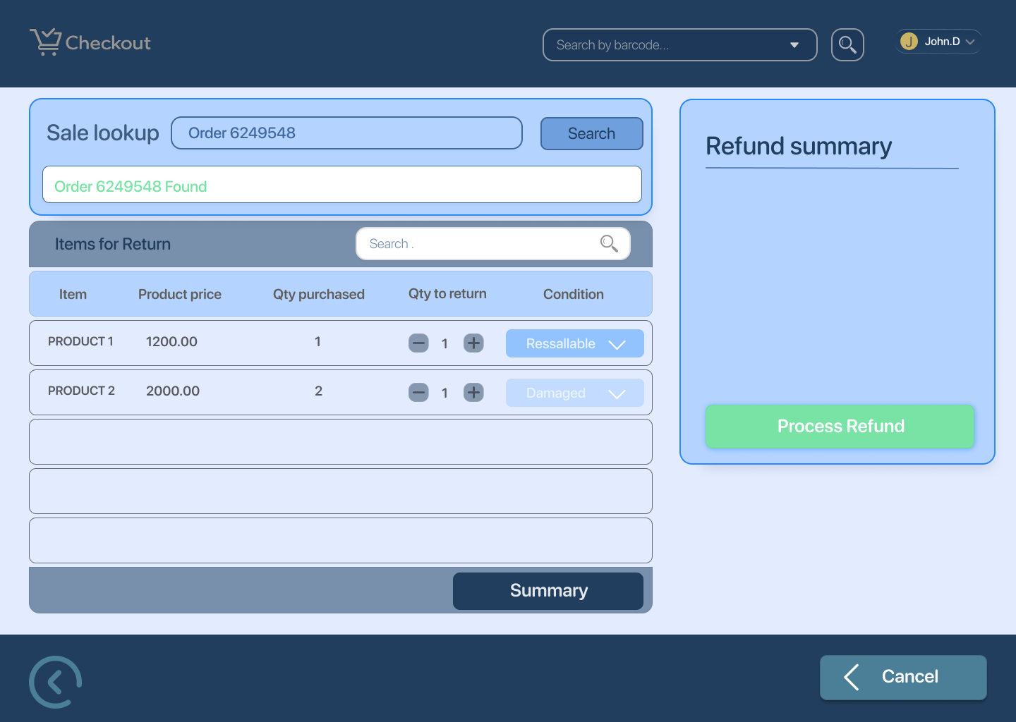

**Item return 3 – Order found**  
Order details confirmed for return flow

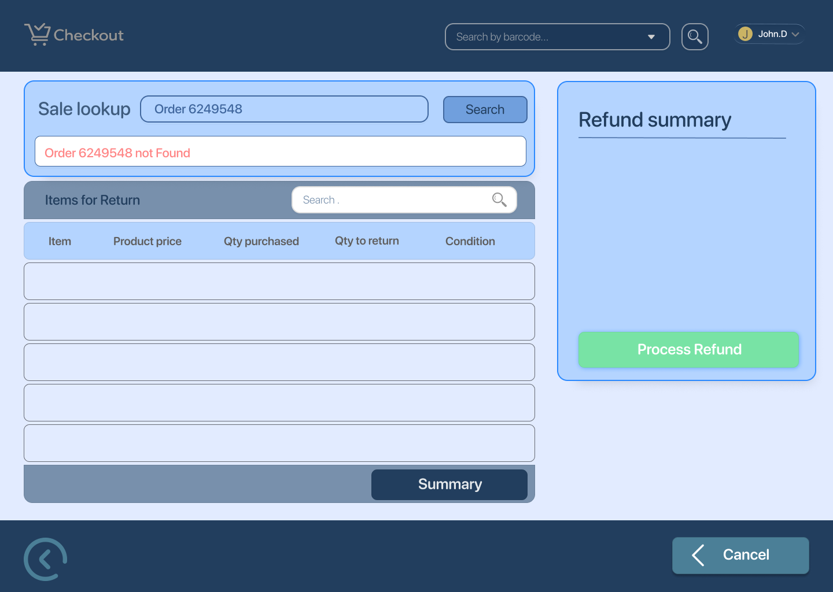

**Item return 4 – Refund summary**  
Selected items and refund amount displayed

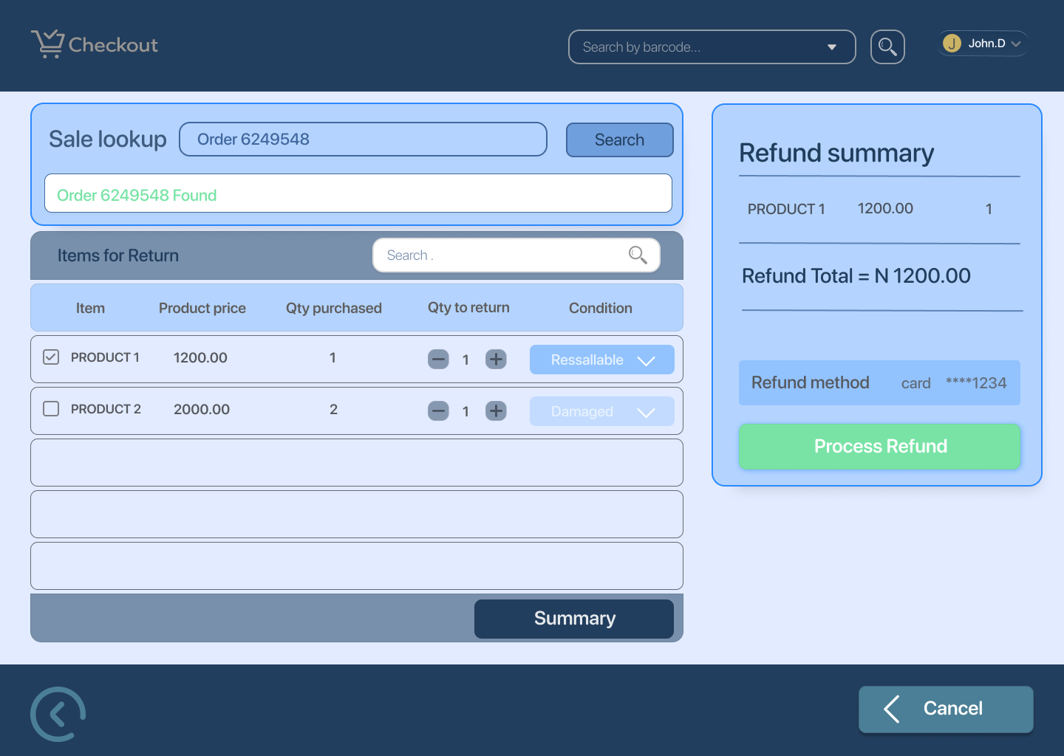

**Item return 6 – Confirm refund pop-up**  
Cashier confirms refund action

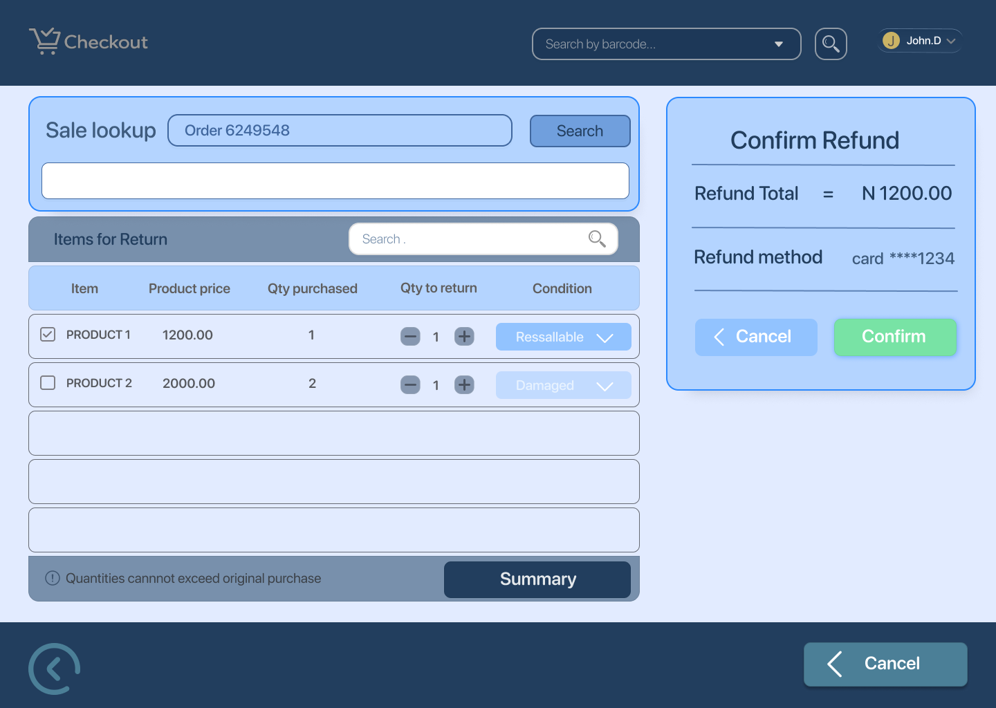

**Item return 7 – Refund processing**  
System processes refund

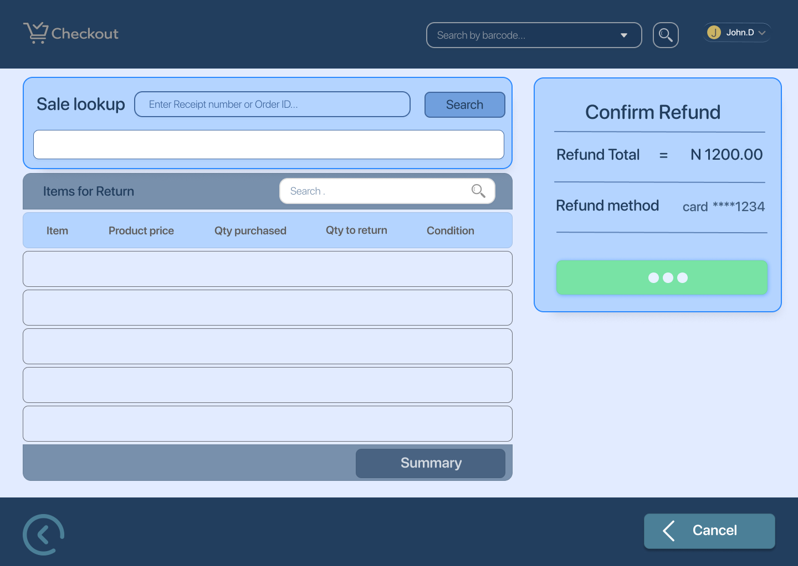

**Item return 8 – Refund confirmed**  
Refund successfully completed

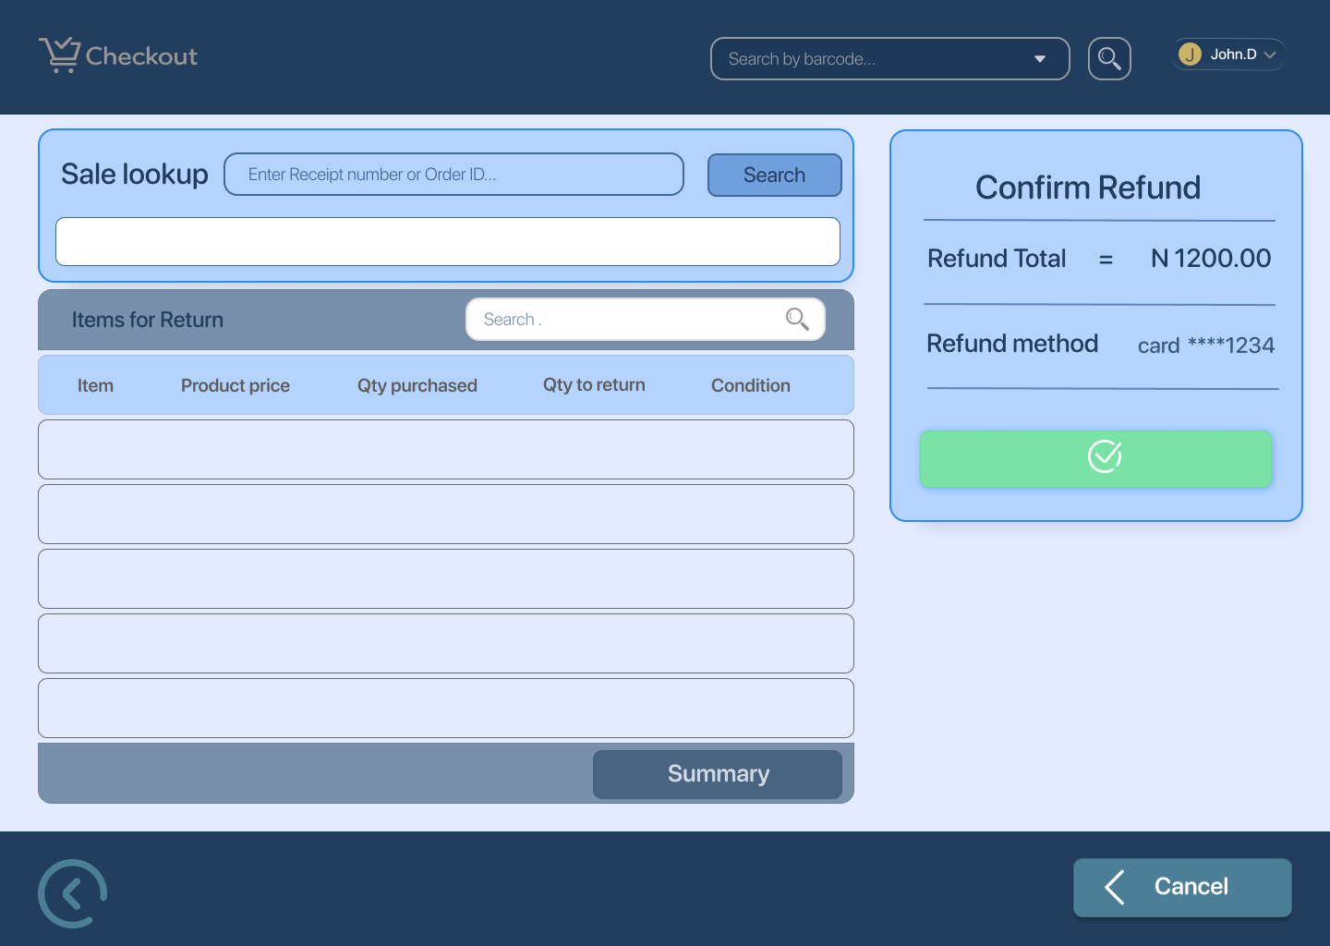

### **Edge Cases / Exception States**

**Item return 5 – Quantities cannot exceed original purchase**  
Validation error when return quantity is higher than purchased quantity

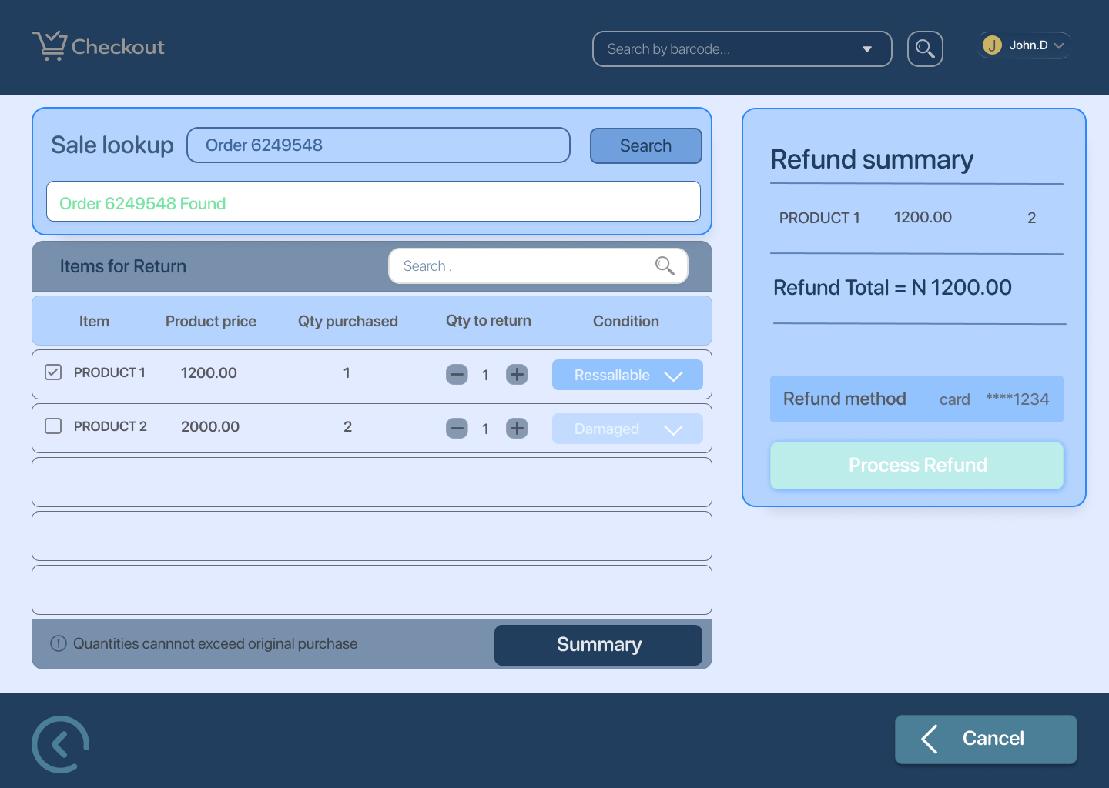

**Item return 9 – Refund not allowed error / item beyond return window**  
Return blocked due to policy violation

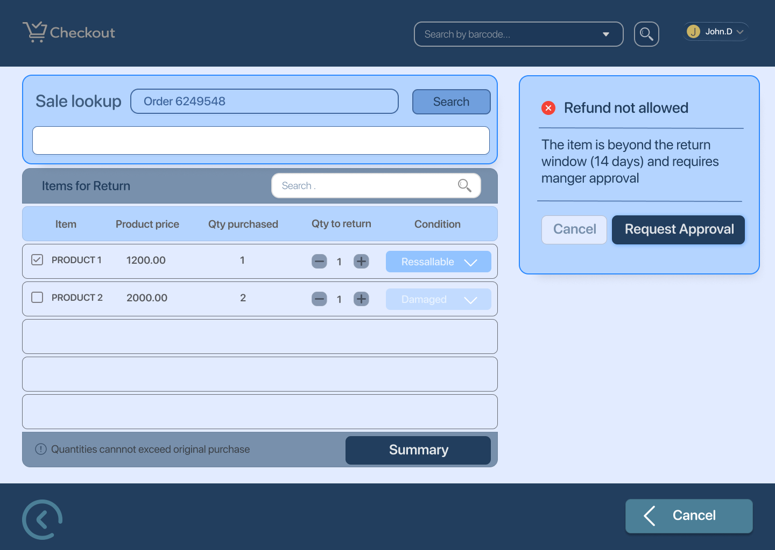

**Item return 10 – Request sent for review**  
Return requires approval and is escalated for review

### **UX Notes**

* Clear status messaging at each step (found, processing, confirmed)
* Validation errors shown inline and explained simply
* Confirmation pop-up prevents accidental refunds
* Processing state blocks duplicate actions
* Error and review states provide clear next steps to cashier